Decoding Innovation Dynamics in Generative AI: A Patent-Based Topic Modelling and Diffusion Theory Approach

Student: Lilit Poghosyan
StudentID: i6372083
Supervisor: Rohan Nanda
2nd reader: Niels Holtrop
Defense Date: July 2, 2025

Acknowledgements

Abstract

This thesis investigates the evolving innovation landscape of Generative Artificial Intelligence (GenAI) through large-scale patent analysis. Given the exponential rise in GenAI patent filings in recent years, there is a growing need to understand the thematic directions shaping this rapid technological progress. Focusing exclusively on GenAI patents, this study applies and evaluates topic modeling algorithms to uncover latent thematic structures and track their evolution. A dedicated preprocessing pipeline was developed to clean and structure the extensive textual data, ensuring accurate and meaningful topic extraction. The results reveal dominant areas of innovation, notable shifts in technological focus, and the emergence of new subfields within GenAI. To contextualize these findings, the Diffusion of Innovations framework, a well-established business theory, offers theoretical grounding to understand how GenAI technologies progress through different stages of adoption. This conceptual foundation further captures how technological innovation unfolds, helping inform early adoption, targeted investment, policy development, and long-term R&D strategies.

Keywords: Generative AI, Innovation Trends, Patent Analysis, Topic Modelling, Diffusion of Innovations

Table of Contents
Chapter 1 6
Introduction 6
Chapter 2 8
2.1 Literature Review 8
2.2 Theoretical Framework 13
Chapter 3 15
3.1 Dataset Retrieval Strategy 15
3.2 Query Design and Conceptual Structure 16
3.3 Dataset Description 19
Chapter 4 21
Methodology 21
4.1 Data Preprocessing 21
4.3 Topic Modelling Approach 23
Chapter 5 26
Results and Analysis 26
5.1 Quantative Evaluation 26
5.2 Qualitative Evaluation 29
5.3 Thematic Evolution of Generative AI Patents 33
5.3 Mapping Innovation Stages in Generative AI 40
Chapter 6 45
Conclusion and Future Work 45
References 46
Appendicies 51

List of Figures and Tables

Chapter 1

Introduction

Technological business innovation is essential for organizations to gain a competitive edge in today’s increasingly interconnected, knowledge-driven global economies. The artificial intelligence (AI) industry plays a strategic role in this context, reshaping competition across sectors. Patents in this process encourage inventors by providing a temporary monopoly in return for their investment in research and development, particularly in fast-growing fields like digital technologies and AI (Hall & Harhoff, 2012). Generative AI, with its transformative potential, stands out among AI subfields for its applications in art, content creation, and synthetic data generation (Sengar, Hasan, Kumar, & et al., 2024). Recent advancements, especially in generative pre-trained transformer (GPT) models, enable near-human intelligence and drive innovation across industries (Dhingra, Singh, SB, Malviya, & Gill, 2023). Reflecting this trend, the number of Generative AI patent applications has increased from around 700 in 2014 to over 14,000 by 2023, with more than 25% filed in the past year alone (WIPO, 2024). This rapid growth signals the field’s transformative potential and highlights the urgency of understanding its innovation dynamics. However, comprehensive studies that systematically analyze Generative AI patent data to identify thematic trends and innovation dynamics remain limited. Existing research often emphasizes static inventor networks or isolated textual patterns, offering limited insights into how innovations evolve or how organizational collaborations and technological focus areas shift over time. Additionally, despite the exponential rise in patent filings, the innovation landscape of Generative AI remains poorly understood, and there is a lack of structured analysis to reveal how key technological themes emerge and develop over time.
This research addresses the problem of limited, fragmented insight into the innovation dynamics of Generative AI. It applies a comparative topic modeling approach to patent documents to fill this gap, extracting thematic trends and tracking their evolution from 2021 onward. The focus is on identifying technological developments and emerging innovation patterns based on the content of patent abstracts and claims while excluding legal, ethical, or geographical interpretations. While the dataset includes patent applications from multiple countries, this study does not examine regional or geographical differences.
To explore the innovation landscape of Generative AI and support both academic and practical understanding, this study formulates the following research questions:

RQ1: Which topic modeling algorithms produce the most coherent and practically interpretable themes when applied to Generative AI patent data?
RQ2: What are the dominant and emerging innovation themes in Generative AI patents filed, and how do these evolve?
RQ3: How can the thematic insights extracted from these patents inform strategic innovation decisions and reveal unexplored opportunities within the Generative AI ecosystem, particularly when framed by the Diffusion of Innovations (DoI) framework?

Three main contributions are evident in this study. First, it advances methodological literature by comparing traditional and advanced topic modeling approaches, including LDA, LSI, NMF, and BERTopic, applied to patent data. Second, it provides empirical insights into the evolution of Generative AI innovations by identifying key thematic developments and emerging trends, thereby enhancing our understanding of the progression of AI technologies. Third, by integrating the Diffusion of Innovations (DoI) framework, the study qualitatively interprets innovation themes along stages of adoption (e.g., early adopters, majority, laggards), helping to identify strategic gaps, assess technological maturity, and uncover high-potential areas for investment and innovation. These findings offer actionable intelligence for R&D managers, policymakers, and investors seeking to align innovation strategies with emerging trends in Generative AI. Using a subject-specific international patent dataset from the European Patent Office (EPO) and focusing exclusively on Generative AI enhances the study’s novelty and practical relevance. The thesis is structured as follows to support the investigation of the stated research questions. Chapter 2 reviews methodological approaches and theoretical frameworks in innovation research. Chapter 3 outlines the research design, including data collection, preprocessing, and modeling procedures. Chapter 4 presents the model comparison and evaluates performance using established metrics. Chapter 5 explores the thematic innovation landscape and interprets key trends. Finally, Chapter 6 concludes with reflections on the study’s contributions, limitations, and future research directions, underscoring the practical implications of the findings.

Chapter 2

2.1 Literature Review

The study of technological innovation has utilized various methodologies to analyze advancements and their impacts across different industries. Standard techniques in this field include natural language processing (NLP) methods such as topic modeling, text analysis, large language models (LLMs), and citation and network analysis. These approaches help uncover patterns, structures, and thematic trends within patent and publication data. This review organizes existing research into three core methodological categories: text analysis, topic modeling, and network analysis. It critically examines how each method has been used to study Generative AI (GenAI) and broader AI innovations. The discussion outlines implementation strategies, key findings, and contributions of each method while highlighting ongoing limitations, including issues with model interpretability, the use of outdated data, and methodological fragmentation. Overall, the reviewed literature enhances our understanding of GenAI innovation dynamics while revealing significant gaps for future research.

Topic Modeling
Topic modeling has emerged as a powerful tool for discovering latent themes in collections of innovation data, such as patent documents or academic publications. By clustering frequently co-occurring terms, topic models reveal the major research fronts or application areas without predefined categories (Kherwa & Bansal, 2019). Singh et al. (2024) conducted one of the first patent text-mining studies on GenAI, applying Structural Topic Modeling (STM) to 2,398 patents filed between 2017 and 2023. The study aimed to identify key application areas and future development of the project. A key advantage of STM is its ability to incorporate metadata (in this case, patent publication year) to detect temporal shifts in topic prevalence. Similiarly, topic modeling was applied to GenAI patents to identify six thematic clusters, ranging from medical applications to cyber-physical systems, which were subsequently mapped through technology roadmaps. The strength of these studies lies in their data-driven taxonomies and the potential for actionable insights for R&D strategy and policy, empowering the audience with valuable information and inspiring them to contribute to this area of research. The use of STM allows for the detection of temporal dynamics and inter-topic correlations, such as overlaps between image generation and conversational agents in multimodal AI. However, both are constrained by static datasets that may not capture post-2023 developments, such as the rising role of GenAI in coding or legal applications. Moreover, the subjectivity in labeling topics and the inherent limitations of unsupervised models remain challenges. On the scholarly side, Dwivedi et al. (2023) used STM to analyze AI-related publications in the journal Technological Forecasting and Social Change (TFSC), identifying eight core themes, including AI in healthcare, sustainable supply chains, and AI-driven decision-making. The study offer a valuable cross-disciplinary review of Generative AI, a subset of AI that focuses on creating new content or data, such as images or text, based on existing patterns or examples. However, several limitations reduce its effectiveness in understanding the dynamics of innovation and strategic application. The framework proposed in the paper is primarily conceptual, relying on high-level taxonomies without empirical validation. While this helps organize existing knowledge, it limits the framework's real-world applicability, particularly in relation to the societal, regulatory, and technological impacts of GenAI. Future research would benefit from grounding such frameworks in quantitative studies or domain-specific case analyses to enhance their practical relevance.
Another significant limitation is the omission of the innovation and intellectual property dimension. Although the paper discusses technical capabilities and ethical challenges, it does not engage with patent activity, technological convergence, or innovation diffusion. These are critical for understanding how GenAI technologies emerge and spread across industries. Ignoring these aspects leaves a significant gap in capturing the market dynamics and competitive structures that define the innovation landscape. Furthermore, the framework presented is static and lacks adaptability to rapid developments in the GenAI field. With continual advances in AI models, shifting regulatory environments, and evolving adoption patterns, a fixed taxonomy risks becoming outdated. Incorporating dynamic or longitudinal approaches such as trend monitoring or innovation lifecycle analysis would improve the utility and longevity of such frameworks. Without this adaptability, the model's relevance diminishes in the face of GenAI's fast-paced evolution. Gupta et al. (2024) extended this approach with a systematic review of 1,319 GenAI-related publications from 1985 to 2023. Their use of topic modeling, combined with bibliometric filtering, revealed clusters related to both applications (e.g., image generation) and theoretical concerns (e.g., privacy, GPT-specific research). While offering a comprehensive roadmap for future research, the study's broad timespan raises issues of thematic consistency over time. For example, the meaning of "generative" in early genetic algorithm studies differs significantly from its usage today. Nevertheless, their inclusive data sources and empirically grounded classification strengthen the study's value, motivating further exploration. Topic modeling has also been applied in related domains of AI innovation. Zhang et al. (2021) applied LDA-based topic modeling to blockchain patents, segmenting technological development into lifecycle stages and identifying innovation trends. While methodologically thorough and provides a structured view of technological evolution, its limitations are notable. The use of cosine similarity to measure relationships between topics, when paired with LDA's bag-of-words assumptions, may fail to capture deeper semantic or contextual linkages. Additionally, the dependence on expert-driven parameter tuning for LDA diminishes the method's scalability and objectivity, limiting its automation potential. Despite known limitations, LDA's transparency and reproducibility offer significant advantages over more advanced and less interpretable models.
This study mitigates some of these constraints by combining LDA results with temporal metadata and domain-specific filtering. It leverages the model's strengths to generate actionable insights into the evolution of Generative AI technologies.

Network Analysis and Citation-Based Analysis
Network analysis has long been central to innovation research, especially through co-authorship, co-citation, and patent citation networks. However, traditional techniques are increasingly criticized for their static and descriptive nature. Classic approaches such as main path analysis or modularity-based clustering often rely on binary, rigid relationships (e.g., a patent cites another = 1, else 0) that fail to capture the semantic nuance, directionality of influence, or contextual depth (Duch & Arenas, 2005). Liu et al. (2021) constructed a citation network to trace the flow of AI innovation; however, their approach focused solely on structural relationships, overlooking content-based similarities and the influence of strategic citation behavior. This limitation is particularly relevant in the context of Generative AI, where citation patterns may be intentionally distorted, for instance, through limited patent disclosure or the avoidance of traditional publication channels by companies aiming to protect competitive advantages. Recent evidence from studies on patent-paper pairs suggests that once a patent is granted, the citation rate of the corresponding scientific publication declines, an effect known as the anti-commons phenomenon. In fast-moving domains like Generative AI, citation patterns underrepresent proper knowledge diffusion, especially when innovations are protected by IP or developed in competitive industry settings (Murray & Stern, 2005). More importantly, traditional network analysis is increasingly regarded as methodologically inadequate for capturing the complexity and rapid evolution of technologies such as Generative AI. It treats nodes (e.g., papers, patents, inventors) as isolated units, whereas real-world innovation systems are often multi-level, dynamic, and non-linear. The method assumes static topology even though GenAI collaborations and influence networks shift rapidly, often within months. Additionally, basic network metrics (centrality, degree, clustering coefficient) are descriptive, not explanatory, they reveal who is connected but not why or how that affects innovation outcomes (Saxena & Iyengar, 2020). Network analysis has become a blunt tool in an era that demands finer, more adaptive instruments. Choe et al. (2013) used centrality and topological measures to identify influential patents. However, their exclusive reliance on patents excluded non-patented innovations like open-source contributions, representing a significant portion of technological advancements. Furthermore, the lack of temporal analysis limits understanding how networks evolve. Obreja et al. (2024) offered a conceptually nuanced view of AI innovation by combining keyword and citation networks to map ethical and societal discourses. Their study focuses on 1,225 social science articles published between 2000 and 2023. One of their central aims was to uncover non-economic dimensions of AI innovation, such as ethical, cultural, and social factors, that are often secondary to technical and economic analyses. Their analysis reveals a clear shift in the AI innovation discourse, particularly between 2021 and 2023, from a focus on technical performance to ethical governance and corporate social responsibility (CSR) themes. While “technology” and “performance” continue to dominate the discourse, there has been a noticeable increase in the prominence of terms such as “transformation,” “ethics,” and “CSR.” This shift indicates a growing scholarly interest in how AI-driven change can be guided and managed responsibly, emphasizing social sustainability and ethical considerations. Obreja et al. (2024) identified 163 influential papers that explicitly address these non-economic aspects, helping to legitimize emerging discussions around ethical AI, social acceptance, and the human and organizational capabilities required for meaningful innovation in generative AI. Interestingly, even within this socially oriented literature, the technological component still dominates, underscoring the hybrid nature of AI innovation as both a technical and social process. A major contribution of the study lies in its mixed-methods approach: the authors combine bibliometric network mapping (e.g., co-citation and keyword networks) with qualitative analysis. For instance, when a citation cluster forms around themes like “ethical AI governance,” the authors move beyond quantitative metrics to interpret the underlying content, uncovering calls for transparency, the development of new ethical frameworks, and innovative governance models. This qualitative layer adds contextual richness and analytical depth, strengthening their conclusions and avoiding the limitations of a purely data-driven network analysis. However, a key limitation is their focus exclusively on social science literature. By intentionally filtering out economic and technical papers, the study misses how these dimensions interact with ethical or cultural considerations. While rising and falling trends in topics are identified, the underlying evolution of the network itself, such as how new actors reshape the topology or how knowledge flows diversify, is rarely modeled in detail. As the volume of generative AI research grows, there is clear potential for more fine-grained dynamic network approaches. Future work could incorporate simulation or predictive modeling to explore how citation or collaboration networks might evolve, for instance, whether the GenAI landscape will consolidate around a few dominant actors or become increasingly decentralized and democratized (Krakowski, 2025).

Hybrid and AI-Enhanced Frameworks (LLMs)
To address the limitations of traditional methods, recent work has begun incorporating large language models (LLMs) into innovation mapping. Wang et al. (2024) propose LLM-based semantic knowledge graphs to reveal conceptual similarity between patents, even when citation links are absent. These graphs reveal latent connections, such as methodological overlaps between domains like "music" and "protein" generation, that may facilitate cross-domain innovation. By clustering conceptually related innovations, even when inventors are unaware of each other's work, they offer a more organic and integrated view of the innovation landscape. Toetzke et al. (2023) propose using large language models (LLMs) to automate the monitoring of climate technology innovation across unstructured data. Their framework showed the feasibility of LLM-based classification and mapping but also acknowledged risks like data sparsity and hallucination, especially in prompt-based or zero-shot learning setups. The study provides a compelling vision of scalable innovation monitoring, but its reliance on general-purpose LLMs calls for further validation through domain-specific fine-tuning and transparent evaluation protocols. Zhou et al. (2024) propose a generative AI framework using large language models for patent analysis. By leveraging zero-shot and few-shot prompting, the authors demonstrate how generative AI can extract structured insights from unstructured patent text, perform semantic clustering, classify patents by novelty and domain, and improve topic modeling. Experimental comparisons reveal that LLM-based approaches consistently outperform traditional methods such as TF-IDF + KMeans and LDA and BERT-based models, particularly in semantic alignment and topic coherence. Despite their strong performance, the study identifies several limitations. First, the high computational cost and latency of models like GPT-4 constrain their scalability in real-world applications. Second, interpretability remains limited, raising legal and regulatory concerns. Third, hallucinations and factual inaccuracies may arise in zero-shot scenarios, potentially undermining the reliability of extracted insights. Finally, domain-specific adaptation continues to be challenging, as general-purpose LLMs may not fully capture the nuanced language of technical or legal patent documents.

2.2 Theoretical Framework

This study adopts Rogers' (2003) Diffusion of Innovations (DoI) theory to provide a conceptual foundation for analyzing the innovation patterns in Generative AI (GenAI) patent data. The DoI framework explains how innovations are communicated and adopted within a social system over time. It has been widely applied in technology adoption studies and is particularly relevant for emerging technologies where development and adoption can differ significantly across actors and contexts. The core idea behind DoI is that innovations diffuse through identifiable stages: knowledge, persuasion, decision, implementation, and confirmation (Rogers, 2003). These stages are reflected in patent activity through filing patterns, the technological focus of patents indicated by their IPC (International Patent Classification) codes, and the involvement of different types of applicants over time. The theory further distinguishes between different adopter types (innovators, early adopters, early majority, late majority, laggards), which can be linked to specific IPC domains or sectors based on the timing and nature of their technological emphasis.
DoI provides a valuable perspective for interpreting topic modeling results, as topics can represent distinct innovation themes that diffuse at different rates (Rogers, 2003) . For instance, some IPC-coded technological areas may emerge earlier and be more concentrated among innovative firms or specific applicants. In contrast, others diffuse later or more broadly across sectors and types of applicants. By mapping topics over time and linking them to IPC trends and applicant activity, this study applies the Diffusion of Innovations (DoI) framework to theorize about the structure and evolution of Generative AI innovation. Given the study’s exploratory focus on thematic patterns in GenAI patents, the Diffusion of Innovations (DoI) framework is used for interpretation rather than prediction. Accordingly, no dependent variables or hypothesis testing are involved. Instead, the theory supports qualitatively interpreting topic lifecycles and technological diffusion trends.

Chapter 3

3.1 Dataset Retrieval Strategy

Generative AI is a relatively new, broad concept without a single dedicated patent classification (WIPO, 2023). Performing a precise patent search for generative AI technologies requires careful query design, as relevant patents often span diverse application domains (e.g., text, image, speech) and may not explicitly use the phrase “generative AI.” This study retrieves patents from the Espacenet database (European Patent Office, n.d.), focusing on the period from 2021 to 2025 to ensure relevance to recent advancements. Drawing from best practices outlined by WIPO (2023), OECD (2020), and the EPO, the search strategy balanced recall (capturing relevant GenAI patents) and precision (excluding irrelevant ones) through iterative refinement using Boolean logic, proximity operators, and IPC/CPC classifications. The query was restricted to the title, abstract, and claims fields to prioritize documents where GenAI was central to the innovation. Classification codes were used to support the search within relevant technical domains. The WIPO Patent Landscape Report – Generative AI (2023) provides a detailed search methodology tailored for GenAI patents. According to the report, analysts successfully combined keyword queries, such as "generative* NEAR3 (AI OR artificial intel* OR adversarial)," with CPC/IPC classification filters to ensure high relevance. This hybrid approach highlights the importance of balancing broad keyword retrieval with domain-specific classification restrictions to achieve both recall and precision. Similarly, the OECD working paper "Identifying and Measuring Developments in AI" (2020) outlines a comprehensive three-pronged search strategy highly applicable to GenAI. The approach involves retrieving patents classified under specific AI-related CPC/IPC symbols, performing a keyword search within full-text patent data, and executing hybrid searches that combine classification codes and keywords. This method stresses the value of using specific classification codes to define the relevant technology domain while supplementing them with carefully selected synonymous keywords. Furthermore, the OECD emphasizes the necessity of manual validation to eliminate false positives, ensuring that retrieved patents genuinely belong to the intended AI domain.
Regarding technical guidance, the EPO Espacenet Pocket Guide (2020) explains Espacenet’s advanced search functionalities. The guide stresses the correct use of wildcard operators (such as *, ?, #) for managing spelling variations and truncation, emphasizes the importance of using parentheses for structuring Boolean queries and explains how Boolean logic can be applied across multiple search fields. Overall, by synthesizing the strategies outlined in these reports, researchers can optimize their patent searches in the Generative AI domain.
While some studies have employed hybrid methods involving both traditional queries and AI-based semantic filtering (BERT classifiers), this research adopts a purely query-based retrieval strategy based on four core considerations: (1) the query was iteratively refined to ensure comprehensive coverage of generative AI patents via keyword variants, technical phrases, proximity constraints, and CPC/IPC codes; (2) this rule-based approach ensures transparency and reproducibility, allowing for straightforward replication; (3) limiting the search to specific patent fields (title, abstract, claims) reduces noise and enhances precision; and (4) Espacenet supports complex Boolean and classification queries, making it a suitable platform. While AI-based retrieval offers semantic depth, a domain-informed Boolean strategy achieves high precision and recall in a reproducible manner.

3.2 Query Design and Conceptual Structure

A structured and precise search strategy was developed in this study to identify patents relevant to Generative AI (GenAI). The query focused on three core conceptual blocks: (1) foundational GenAI architectures, (2) supporting model structures, and (3) real-world generative applications. The strategy employed Boolean logic, proximity operators, and classification codes to construct a high-precision search tailored to the nuances of patent language. The search targeted only the title, abstract, and claims fields to ensure relevance and minimize noise from less informative sections. The first conceptual block targeted established GenAI models such as GANs, VAEs, diffusion models, and large-scale transformers. It included patterns like (GENERATIVE* +2W ADVERSARIAL +2W NETWORK*) and brand-specific terms like GPT#3*. The second block broadened the scope to cover general architectures—such as TRANSFORMER*, AUTOENCODER*, and LLM—used to describe generative models in broader AI terminology. The third block captured real-world applications by combining data modalities (e.g., IMAGE*, TEXT*, VIDEO*) with generative actions (e.g., GENERATE*, CREATION).To reduce irrelevant results and increase domain specificity, the strategy incorporated relevant IPC/CPC classifications. These ranged from core classes like G06F*, G06N*, and G06T* to application-specific codes such as G16H* (healthcare) and G10L* (speech processing). These classifications were iteratively refined using tools like the EPO’s CPC Text Categoriser (European Patent Office, n.d.) and through manual validation of retrieved results. A publication date filter (PUD > 2020) ensured a focus on recent innovations following the release of foundational models like GPT-3. The search strategy evolved through iterative testing. Initial queries produced false positives related to generative design in unrelated fields. To address this, proximity constraints (e.g., "generative" +1W "AI") and additional keywords (e.g., "diffusion model," "VAE") were introduced. Manual inspection of the retrieved documents guided each refinement step, ensuring that relevant improvements did not come at the cost of coverage. This refined, domain-specific, and classification-enhanced strategy enabled transparent, reproducible, and targeted retrieval of patents at the core of GenAI innovation.

TIEN ABEN CLEN = ( (GENERATIVE* +2W (AI OR "ARTIFICIAL INTELLIGENCE" OR ADVERSARIAL) OR (GENERATIVE +2W PRE#TRAINED) OR (PRE#TRAINED +3W ("LANGUAGE MODEL" OR TRANSFORMER?)) OR CHAT#GPT OR (VARIATIONAL +2W AUTOENCODER?) OR (GENERATIVE +2W ADVERSARIAL +2W NETWORK*) OR (DIFFUSION +2W PROBABILISTIC +2W MODEL?) OR (AUTO#REGRESSIV* +2W MODEL*)) OR (GENERATIVE* +3W (AI OR "ARTIFICIAL INTELLIGENCE" OR ADVERSARIAL) OR (GENERATIVE +2W PRE#TRAINED) OR (PRE#TRAINED +3W ("LANGUAGE MODEL" OR TRANSFORMER?)) OR CHAT#GPT OR (VARIATIONAL +2W AUTOENCODER?) OR (CONVOLUTIONAL +2W GENERATIVE +2W ADVERSARIAL +2W NETWORK*) OR (DIFFUSION +2W PROBABILISTIC* +2W MODEL?) OR (DIFFUSIONAL +2W NETWORK?) OR (DENOISING +2W DIFFUSION +2W PROBABILISTIC +2W MODEL?) OR (GENERATIVE +2W LATENT +2W OPTIMIZATION) OR (NEURAL +2W RADIANCE +2W FIELD) OR (AUTO#REGRESSIV* +3W MODEL*) OR GAN OR GANS OR GENAI OR VAE OR VAES OR ((DENOISING OR VIDEO OR MODELS OR STABLE) +3W DIFFUSION* +2W MODEL*) OR (VARIATIONAL +3W AUTOENCODER*) OR GPT#3* OR GPT#4*)
OR
(TRANSFORMER* OR AUTOENCODER* OR LLM OR "LARGE LANGUAGE MODEL*" OR GAN OR (GENERAT* +3W ADVERSARIAL +3W NETWORK*) OR (AUTO#REGRESSIV* +3W MODEL*) OR (DIFFUSION +3W PROBABILISTIC +3W MODEL*))
OR
(((IMAGE* OR TEXT* OR VIDEO* OR SPEECH* OR ("3D" +1W MODEL*) OR "GENE SEQ*" OR DESIGN OR PROGRAM* OR COMPUTER* OR SOFTWARE* OR CODE* OR MUSIC* OR SCENE* OR MOLECULE* OR "SYNTHETIC DATA*" OR "WORD SEQUENCE*" OR "WORD SEQUENCES*") OR (GENERATE* OR GENERATING* OR GENERATION* OR GENERATIVE*)) AND (GENERATIVE* +3W MODEL*)))
AND
((IPC = (G02B* OR G01N* OR B23Q* OR A61B* OR G06F* OR G06N* OR G06Q* OR G06V* OR G10L* OR G16H* OR H04L* OR H04N* OR G06T* OR G06K* OR G01M* OR Y02D*)) OR (CPC = (A63F* OR G02B* OR G01N* OR B23Q* OR A61B* OR G06F* OR G06N* OR G06Q* OR G06V* OR G10L* OR G16H* OR H04L* OR H04N* OR G06T* OR G06K* OR G01M* OR Y02D* OR G10H* OR H04Q*)))
AND

(PUD > 2020)

Figure 1. Patent Search Query

Search Validation Process

To ensure that the Boolean query accurately captured patents relevant to Generative AI (GenAI), the study followed a multi-step validation process focused on both recall (completeness) and precision (relevance). First, the query was benchmarked against a list of well-known GenAI patents from leading organizations. The absence of key patents indicated terminology gaps, so new keywords and model names were added. A random sample of retrieved patents was manually reviewed to identify false positives. For instance, confusion between "GAN" (generative adversarial network) and "GaN" (gallium nitride) highlighted the need for exclusion terms and more refined expressions, such as substituting “generativ*” for the broader “generat*”. The study compared parallel queries with and without full-text fields to enhance coverage. Relevant patents retrieved only from full descriptions were analyzed to extract missing terms, which were subsequently integrated into the core query.
Additionally, independent searches based solely on CPC classifications (e.g., G06N 3/0475, G06N 3/048) were cross-referenced with the keyword-based results to identify any relevant patents that may have been omitted. Terms from these patents were also incorporated to strengthen the query. Throughout this process, the query was tuned to favor recall to avoid missing relevant innovations, even if that meant accepting a small degree of noise. To improve clarity and manageability, the search strategy was modularized by GenAI subtypes (e.g., GANs, diffusion models) and iteratively refined for interpretability. This comprehensive validation ensured that no significant area of GenAI innovation was overlooked, resulting in a robust and reproducible search strategy tailored to patent data from 2021 to 2025.

Known Limitations and Risks

Despite a structured and validated search design, several limitations remain common in large-scale patent retrieval, particularly in fast-evolving fields like Generative AI (GenAI).
Terminology Drift and Emergence. GenAI's evolving language presents challenges. While the query includes established and emerging terms (e.g., “GPT,” “diffusion model,” “transformer”), it may miss very recent terms like “foundation models” or older patents using unconventional phrasing (e.g., “image synthesis network” instead of “GAN”). Broad classification codes help mitigate this, but gaps remain inherent to keyword-based approaches.
Inconsistent Patent Language. Descriptions of Generative AI in patents may rely on non-standard or inconsistent terminology. For example, a GAN might be called “a dual-network system” without the acronym. While classification filtering (e.g., G06N 3/0475) reduces this risk, inconsistently labeled patents may still be missed.
Classification Gaps and Misassignment. IPC/CPC codes, though valid for domain specificity, are not always consistently applied, especially when GenAI is a secondary feature. Some patents may be misclassified or assigned only to general technical areas, making them harder to capture.
False Positives from Semantic Ambiguity. Keywords like “GAN,” “generator,” or “transformer” can produce irrelevant results:

- “GAN” may retrieve GaN (gallium nitride) patents.
- “Generator” may refer to power systems.
- “Transformer” can mean electrical hardware.
- “Synthetic data” and “generative design” may appear in non-AI contexts.
Platform and Syntax Constraints. Espacenet limits query length and complexity. Syntax rules (e.g., wildcard placement, proximity operators) were carefully followed to keep the search consistent.
While no search strategy is error-free, this approach balances recall and precision through layered filtering, validation, and iterative refinement.

3.3 Dataset Description

The dataset used in this study comprises 1,570 patent records retrieved from the European Patent Office (EPO) via the Espacenet platform, covering the years 2021 to 2025. These patents were downloaded initially in XML format, allowing structured extraction of both textual content and metadata. From each XML file, 20 fields were extracted, of which 16 were deemed relevant for analysis. Key fields used in the study include the patent title, abstract, claims, description, publication year, IPC classification codes ,applicant and a unique patent identifier. These components were prioritized for their importance in both identifying technical focus and enabling further textual analysis. Specifically, the title, abstract, and claims fields were used for topic modeling, as they consistently contain concise and informative descriptions of the core innovation.
In contrast, the description field was excluded from modeling due to its redundancy, and inclusion of boilerplate language, which may introduce noise into unsupervised learning processes. Patent records missing either abstract or at least one claim were removed to ensure consistency and analytical value. These omissions typically resulted from jurisdictional differences or incomplete data entries. After applying this completeness filter, the dataset was reduced from 4,001 to 1,570 high-quality, complete patent records. The final dataset thus provides a robust, reproducible, and domain-specific foundation for semantic analysis and innovation mapping in the Generative AI (GenAI) domain.

Chapter 4

Methodology
Overview and Research Strategy
The methodology focuses on applying topic modeling to uncover latent thematic structures within patent documents and to track their evolution over time. A comparative modeling approach was employed to evaluate the performance of multiple topic modeling algorithms on the same dataset, ensuring robustness and consistency in the results.

4.1 Data Preprocessing
Due to their unstructured nature, patent documents require comprehensive preprocessing to be suitable for analytical tasks such as topic modeling. Abstract has been the primary focus of prior patent text analysis, as it typically encapsulates the core technical contribution of the invention. Preprocessing commonly involves a series of standard operations, including lowercasing, punctuation removal, tokenization, lemmatization, and the elimination of stopwords and low-frequency terms (Fliedl et al., 2013). The study incorporated an extended stopword list to filter out frequently occurring but semantically uninformative terms typical of patent language to improve domain-specific clarity. These included industry-generic vocabulary and legal boilerplate expressions . While stemming is often used in traditional text mining pipelines (Janani & Vijayarani, 2016), this study employed lemmatization instead. Lemmatization preserves grammatical structure and semantic meaning by reducing words to their base forms (e.g., "generating" to "generate") while maintaining syntactic integrity—an important consideration in technical texts. In contrast, stemming can produce non-standard or truncated forms (e.g., "generation" to "gener"), potentially reducing model interpretability. Building on this foundation, the study applied a domain-adapted, multi-stage preprocessing pipeline tailored specifically to Generative AI patent data. The input text was constructed by merging the content of the title, abstract, and claims fields. These components were selected due to their consistent inclusion of technical descriptions and relative clarity compared to the verbose and often legally dense whole description field. The preprocessing steps were as follows:
Normalization: All text was converted to lowercase, and known model names (e.g., GPT-4, DALL·E) were standardized using regular expressions to ensure consistent token representation.
Noise Reduction: Hyphens were replaced with spaces, and standalone numbers, punctuation, and numeric references were removed to eliminate formatting artifacts common in patent language.
Entity Cleaning: A curated list of named entities was used to filter out irrelevant or overly specific terms. Only entities included on a predefined whitelist of domain-relevant concepts (e.g., "transformer," "autoencoder," "convolutional neural") were retained, minimizing conceptual noise.
Stopword Removal: A custom stopword list was developed, including domain-specific and legal boilerplate terms such as "wherein," "apparatus," and "said," which appear frequently in patents but add little value for thematic analysis.
Linguistic Filtering: Part-of-speech tagging was applied to identify and remove generic verbs (e.g., "using," "obtaining," "providing") and adjectives (e.g., "new," "respective," "present") that occurred frequently but lacked discriminative value for topic modeling.
Final Text Construction: After filtering, the remaining text was normalized and collapsed into clean strings suitable for tokenization and model input.
Further refinement included identifying multi-word expressions using Gensim's Phrases model. Frequent domain-specific phrases (e.g., "neural network") were merged into single tokens (e.g., "neural_network") based on co-occurrence and frequency thresholds. Extremely common terms appearing in over 30% of documents were also removed to improve topic distinctiveness and reduce semantic overlap, following standard topic modeling practices (Blei et al., 2003; Sievert & Shirley, 2014). This helped the model focus on more informative and distinctive vocabulary. Finally, tokenized documents were lemmatized using SpaCy, and any single-character strings were removed to enhance semantic clarity. Gensim dictionaries and bag-of-words corpora were then constructed from the cleaned and lemmatized text, providing the input for subsequent topic modeling. This structured, domain-specific preprocessing pipeline ensured that only relevant and meaningful content was retained, ultimately improving the topic models' interpretability and performance.

4.3 Topic Modelling Approach

Four topic modeling algorithms—LDA, LSI, NMF, and BERTopic—were applied to the dataset for exploratory comparison. To optimize model performance and ensure fair comparison, a grid search was conducted for each algorithm to explore multiple hyperparameter combinations. This systematic tuning helped identify the best-performing configurations based on coherence and diversity scores.
LDA/LSI
Latent Dirichlet Allocation (LDA) was employed as the primary probabilistic topic modeling technique due to its capacity to uncover latent thematic structures from unstructured text while offering high interpretability. As a generative model, LDA assumes each document is a mixture of latent topics, with each topic represented as a distribution over words governed by Dirichlet priors. This formulation supports sparsity, meaning that only a subset of topics dominates each document—an assumption well-suited for domain-specific corpora such as patents (Abdelrazek et al., 2023).To identify the optimal LDA configuration, a grid search was performed across three key parameters: the number of topics (k), the Dirichlet prior for document-topic distribution (α), and the Dirichlet prior for topic-word distribution (β). The number of topics was varied from 1 to 20 to evaluate different levels of thematic granularity. A six-topic model was ultimately selected, balancing semantic coherence and topic distinctiveness, and meeting the interpretability requirements of innovation-focused patent analysis. For each combination of parameters, coherence scores (Cv) were calculated to assess semantic quality (see Section 5.1). Alpha values ranged from 0.01 to 0.91, covering both symmetric and asymmetric priors. Lower α values encouraged topic sparsity, which is desirable for modeling focused technical content. Similarly, β was varied across the same range, where lower values promote sharper topic-word distributions and help highlight more distinctive keywords (Gupta et al., 2022). Topic diversity was also evaluated to ensure that selected models yielded not only coherent but also non-redundant topic sets. This dual-metric evaluation helped ensure that the final model produced semantically meaningful and interpretable topics suitable for qualitative analysis. To benchmark LDA, Latent Semantic Indexing (LSI) was also implemented. LSI applies singular value decomposition (SVD) to the term-document matrix to project documents and terms into a lower-dimensional latent space, revealing patterns of term co-occurrence. While LSI is effective at capturing synonymy and latent associations, its utility for topic modeling is limited by its reliance on Gaussian assumptions and the absence of a generative probabilistic framework. Moreover, interpretability is often reduced, as the components do not consistently align with human-understandable topics (Abdelrazek et al., 2023). For LSI, additional hyperparameters were tested—specifically, one_pass (True/False), power_iterations (1–7), and extra_samples (50–250)—which influence the accuracy and stability of the truncated SVD. Topic coherence was calculated for each configuration to enable fair comparison with LDA. Topic modeling and related text transformations were implemented using widely recognized Python libraries for natural language processing and unsupervised learning. The consistency in experimental design across both models supports an objective assessment of their relative performance.
NMF
An extensive parameter tuning procedure was conducted to evaluate the performance of Non-negative Matrix Factorization (NMF). NMF is an algebraic topic modeling technique that decomposes the document-term matrix into two non-negative matrices, producing additive components that improve interpretability. In contrast to the probabilistic nature of LDA, NMF extracts distinct parts-based representations (Abdelrazek et al., 2022). Multiple configurations were tested by varying the number of optimization passes (5 and 10), the kappa parameter (ranging from 0.05 to 1.0), and the maximum number of iterations for the W and H matrices (50, 150, 250). These parameters affect the convergence behavior and stability of the factorization process. Coherence scores were computed for each configuration to identify the most semantically consistent topic structures. Results were stored and ranked to determine the most coherent and interpretable NMF setup.
BERTopic
BERTopic builds on recent advances in transformer-based language models to overcome the semantic limitations of conventional topic modeling techniques like LDA and NMF, which rely on bag-of-words representations and disregard contextual word meanings. By leveraging document-level embeddings (e.g., BERT), BERTopic captures semantic relationships and clusters similar documents using HDBSCAN, a density-based algorithm (Grootendorst, 2022). In this study, BERTopic was applied using two input granularities to explore how abstraction level affects topic representation: (1) BERTopic-chunk, which segmented the patent text into smaller chunks (e.g., paragraph-level) to capture fine-grained thematic variation, and (2) BERTopic-summary, which used full, merged title-abstract-claim texts per patent to extract broader semantic patterns. For both settings, document vectors were generated using MiniLM embeddings and clustered using KMeans. A parameter search was conducted over the number of clusters (2–20) and Maximal Marginal Relevance (MMR) diversity (0.2–1.0) to identify optimal configurations. Topic representations were extracted via a class-based TF-IDF (c-TF-IDF) approach (Qaiser & Ali, 2018) using a CountVectorizer with 1–2 n-gram ranges. Importantly, unlike other models in this study, BERTopic did not apply frequency-based filtering or remove generic terms during preprocessing, allowing for richer contextual interpretation. Final models were evaluated using topic coherence and diversity to assess their interpretability and distinctiveness. This embedding-based clustering approach overcomes the limitations of bag-of-words models by capturing contextual word meanings, enabling BERTopic to produce semantically rich and thematically distinct topic representations
Unlike models such as LDA, NMF, or LSI, which work with term frequencies and typically remove very common words to reduce noise, BERTopic retains all words during preprocessing. This is because it relies on dense vector representations that learn meaning from context, where even frequent terms can carry important semantic information. Removing these words could reduce the model’s ability to fully capture the relationships between concepts. Additionally, BERTopic does not use Gensim’s corpus structure. Instead, it applies the CountVectorizer function from scikit-learn to build its vocabulary and extract n-gram features, supporting richer and more flexible text representation.

Chapter 5

Results and Analysis

5.1 Quantative Evaluation

A comparative evaluation was conducted to address the first research question concerning which topic modeling algorithms generate the most coherent and practically interpretable topics when applied to Generative AI patent data. Quantitative performance was assessed using coherence and topic diversity metrics, while qualitative interpretability was examined through keyword analysis and topic intrusion validation.
To ensure comparability, all models were applied to the same preprocessed dataset under consistent settings. Performance was evaluated using three key quantitative indicators: topic coherence, topic diversity, and overall topic quality. These metrics were selected based on established evaluation practices reviewed by Abdelrazek et al. (2023), as each captures a distinct dimension of interpretability and model utility. Topic coherence is a primary indicator of interpretability, assessing whether the top-ranked words in a topic cohere semantically. As defined by Newman et al. (2010), coherence is often measured using Pointwise Mutual Information (PMI), which quantifies the likelihood of word co-occurrence beyond chance. This metric approximates human judgment, with higher scores indicating that a topic contains terms that frequently appear together in the corpus and thus represent a meaningful semantic group. In accordance with prior studies and best practices, coherence was computed based on the top 10 tokens per topic—balancing interpretability, consistency, and computational efficiency. Abdelrazek et al. (2023). While topic coherence measures the internal consistency of individual topics, topic diversity assesses how distinct the topics are from one another. It is calculated as the proportion of unique words across the top 10 words of each topic relative to the total number of words considered. This metric captures the extent to which the model generates non-redundant, thematically differentiated outputs. Although Abdelrazek et al. (2023) originally define topic diversity using the top 25 words per topic, the current study adopts a top-10 word scope to ensure methodological consistency with the coherence evaluation. A high diversity score indicates that the model successfully identifies a broad range of concepts with minimal vocabulary overlap, an essential quality in patent analysis, where topic redundancy can reduce the analytical value of the results. Conversely, a low diversity score suggests that topics may be reusing similar terms, signaling insufficient conceptual separation or overfitting to dominant lexical patterns (Abdelrazek et al., 2023). To capture both interpretability and distinctiveness in a single measure, a composite topic quality score was calculated. This score was based on the same top-10 word threshold used in the coherence and diversity evaluations to ensure consistency across metrics. While the 10-topic configuration did not produce the highest individual scores for coherence or diversity, it offered a practical balance between the two, avoiding extremes. As noted by Abdelrazek et al. (2023), coherence and diversity often exist in tension: increasing the number of topics typically enhances diversity but can lower coherence, whereas fewer topics may improve coherence while yielding overly broad or overlapping themes. In this study, the 10-topic solution was selected not for maximizing a single metric, but for aligning with the broader objective of topic quality, generating topics that are both interpretable and sufficiently distinct, even if not optimal on either metric alone.
The final evaluation results are presented in Table 1, which compares the top-performing configurations of five topic modeling algorithms based on their coherence, diversity, and composite quality scores.

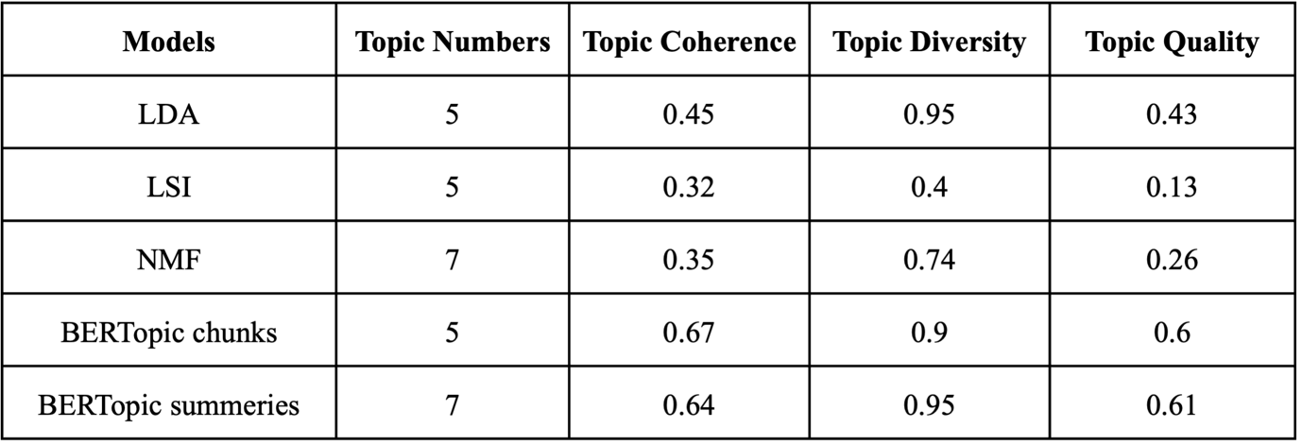
Table 1. Final evaluation of topic models with highest topic quality scores.

The table shows that the BERTopic models, particularly the summary-based variant, demonstrated the highest overall topic quality, while traditional methods such as LDA and NMF achieved moderate performance. These results reinforce the importance of considering both coherence and diversity when selecting models, as no single metric alone provides a complete picture of topic interpretability. In addition to the final evaluation table, the internal performance dynamics of the five models are visualized in Figures 2-6. These plots illustrate how topic coherence, diversity, and composite quality scores vary across topic numbers and configurations.
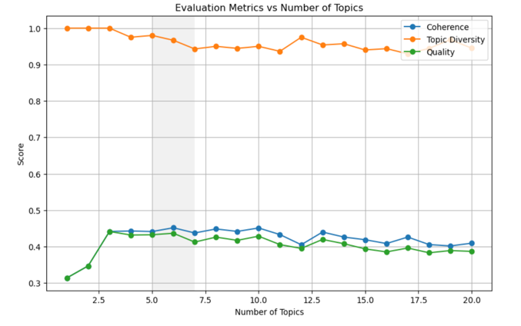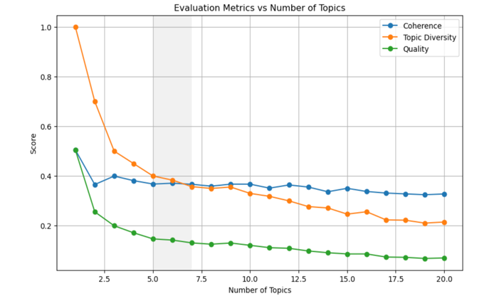
Figure 2. LDA Model Performance Figure 3. LSI Model Performance

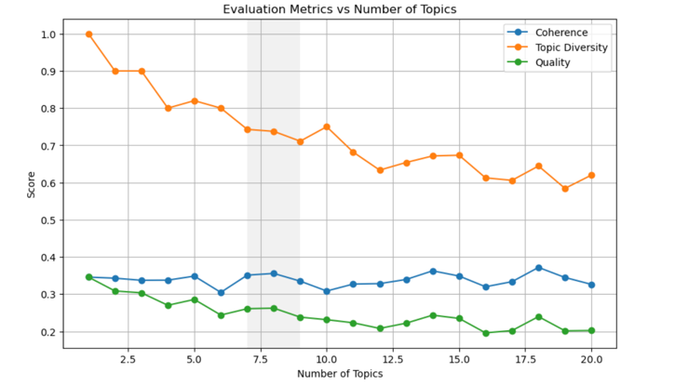
Figure 4. NMF Model Performance

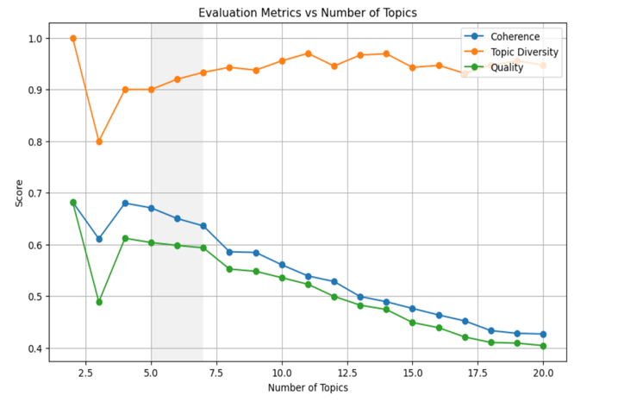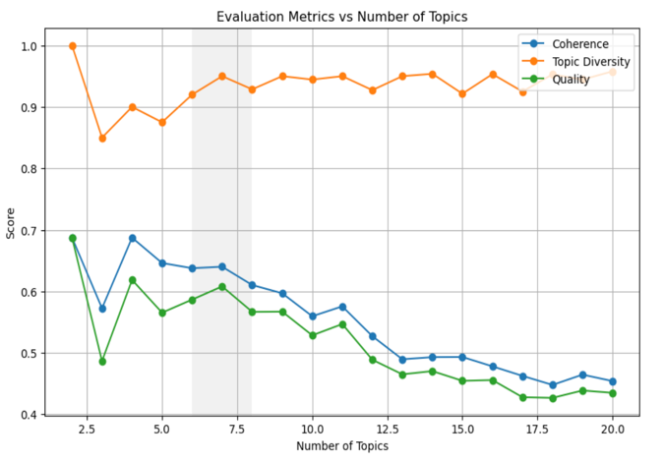
Figure 5. BERTopic chunks Figure 6. BERTopic summaries

Each figure illustrates how topic coherence, topic diversity, and overall topic quality change as the number of topics increases across different models. For LDA (Figure 2), coherence scores show a slight increase between 2 and 10 topics but remain relatively stable overall, indicating that semantic interpretability does not significantly improve with more topics beyond a certain point.Topic quality rises early on and then gradually declines, suggesting that while coherence may not suffer with more topics, the distinctiveness of topics diminishes, affecting overall quality. This pattern implies that a smaller number of topics, particularly between 6 and 10, offers a more effective balance between interpretability and uniqueness. Notably, topic quality peaks at 5 topics, and adding more beyond 10 does not yield meaningful improvements.In contrast, the LSI model shows a different trend. Coherence remains relatively stable across topic counts, but topic diversity steadily declines. This indicates that while the model maintains semantic interpretability, it produces less distinct topics as more are added. As a result, topic quality also drops consistently. These findings suggest that LSI is best suited for extracting a small number of general themes, with maximum topic quality also observed at 5 topics.For NMF, coherence is relatively stable with minor fluctuations, similar to LDA and LSI. However, topic diversity gradually decreases with higher topic numbers, indicating reduced differentiation among topics. Interestingly, topic quality peaks at 7 topics, suggesting that NMF achieves its best balance between coherence and diversity when extracting a moderate number of themes. This makes NMF particularly effective in identifying semantically rich yet distinct topics within Generative AI patent data.In the case of BERTopic (chunk-level), topic coherence starts high at 5 topics but declines steadily as more topics are added. Topic diversity, however, remains consistently strong across all topic counts, generally staying above 0.9. This shows that the topics remain well-separated regardless of the number generated. Yet, as coherence drops, topic quality also declines, indicating that high diversity alone is not enough to sustain overall model quality.For BERTopic applied to patent summaries, the model performs best with a low number of topics, where coherence and diversity are most balanced. As the number of topics increases, coherence weakens while diversity stays high, resulting in a gradual decline in overall topic quality.

5.2 Qualitative Evaluation

Three models emerged as top performers in terms of topic quality: BERTopic (chunk), BERTopic (summary), and Latent Dirichlet Allocation (LDA). Although BERTopic summary ranked second in overall topic quality, its qualitative outputs raised interpretability concerns. Several topics showed significant semantic overlap, for example, terms like face, image, medical image, and imaging appeared repeatedly across Topics 0, 1, 2, 3, and 6. In addition, generic terms such as text, signal, entity, feature, and query were present in multiple topics, reducing uniqueness. More critically, some topics included ambigous or non-informative words such as data, sentence, or loss, which failed to convey clear technological themes (see Appendix A, Table 2). While the model achieved high scores numerically, its outputs were less interpretable from a human perspective. This highlights a limitation of relying solely on quantitative metrics in contexts where interpretability is essential.
Similarly, the BERTopic chunk model generated granular topic groupings, but its interpretability was limited when evaluated qualitatively due to recurring semantic redundancy and abstract vocabulary. As illustrated in Appendix B, Table 3, for instance, Topic 1 (text, sentence, document, language) and Topic 3 (prompt, service, query, language) shared overlapping language related to natural language input, yet lacked clear thematic differentiation. Additionally, broad and non-specific terms such as node, item, content, and performance appeared across several topics, undermining conceptual clarity. Redundant verbs like generate, learn, and training were also common across clusters, further blurring thematic boundaries. Despite maintaining high topic diversity, the BERTopic chunk model produced topics that were conceptually weak and difficult to interpret, making it unsuitable for subsequent thematic analysis in its current form.
In contrast, LDA demonstrated greater semantic coherence and clearer topic separation, as shown in Appendix C, Table 4. Each topic was manually labeled through qualitative analysis of the top-ranked keywords. For example, Topic 0 (feature, sample, layer, generator, discriminator, generative adversarial) was interpreted as Adversarial Image Generation, reflecting adversarial training methods such as GANs, with application-oriented terms like face, recognition, and detection suggesting relevance to visual recognition systems. Topic 1, Language Modeling and Prompt-Based Learning, contained terms pointing to transformer-based NLP systems and instruction tuning. Topic 2, Sequence Encoding and Audio Signal Processing, included signal, sequence, audio, decoder, block, and quantization, indicating a focus on sequential data and multimedia encoding architectures. Topic 3 was labeled Medical Imaging and Diagnostic AI, based on the presence of terms like medical, sensor, segmentation, pixel, and magnetic resonance. Topic 4 focused on Embedded Systems and Signal Transmission, involving low-level AI deployment contexts, while Topic 5 reflected Representation Learning and Autoencoding Methods, with terms such as vector, autoencoder, encoder, and latent indicating unsupervised learning and compression techniques. Although BERTopic models achieved slightly higher composite topic quality scores, the decision was made to adopt LDA for the main interpretation and analysis phase. This choice was driven not only by metric considerations but also by LDA’s practical advantages in transparency and interpretability. Unlike BERTopic, which lacks native support for probabilistic topic distributions across documents, LDA provides per-document topic probability vectors. This structure allows for further validation through techniques such as topic intrusion tests and semantic plausibility checks, which help verify that topic assignments are meaningfully grounded in the text.
Moreover, the topics generated by LDA demonstrated stronger thematic consistency, with less term redundancy and greater alignment with recognizable technological areas. Given the objective of this thesis to trace the thematic directions of Generative AI innovation rather than to optimize performance metrics alone, LDA offers a more methodologically robust and interpretable foundation. Therefore, it was selected as the final model for conducting topic-based analysis in the remainder of the study.

LDA Topic Validation through Topic Intrusion Analysis

To assess whether the LDA-generated topics aligned with human interpretability, a topic intrusion task was conducted, following the method introduced by Chang et al. (2009). For each patent, the model-generated topic distribution was used to identify the top three most probable topics, alongside a randomly selected low-probability intruder topic. A short piece from the patent abstract was presented along with the four topic labels, and the task was to identify the topic that did not semantically fit. If the model's topic assignments are meaningful, the intruder should be clearly identifiable (Chang et al., 2009). In most cases, the intruder topic was easily recognized, suggesting strong alignment between the model-generated topics and the underlying patent content. One illustrative example further highlights this interpretability: patent EP22791474A1, which describes a vibration energy harvesting monitoring device, was assigned three relevant topics, all of which contained terms highly consistent with the patent’s technical focus. In contrast, the intruder topic contained generic language processing terms such as text, sentence, query, and language, which has no semantic relevance to the patent. This clear thematic mismatch made the intruder easily distinguishable (see Figure 7). Similar outcomes were observed across the sample, consistently supporting the interpretability and coherence of the LDA model’s output.
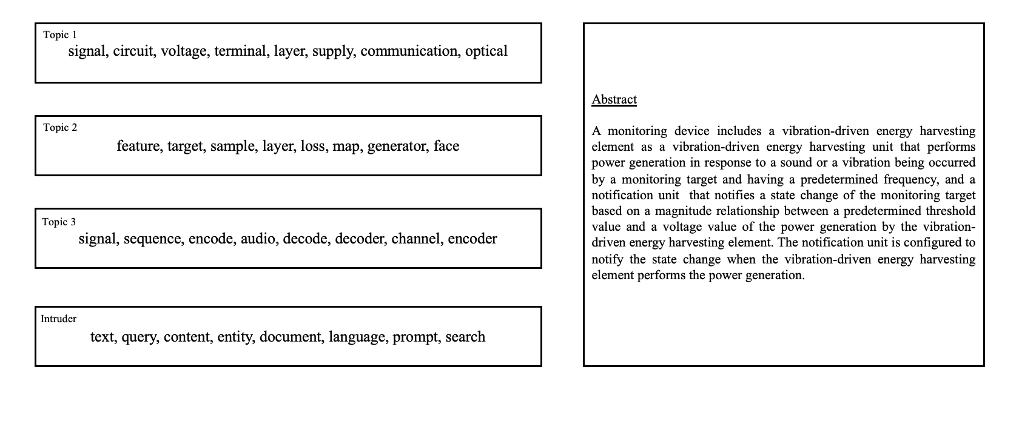
Figure 7. Sample Topic Intrusion Test

To complement the manual evaluation, a Topic Log Odds (TLO) analysis was also performed to systematically evaluate topic coherence at scale. TLO is defined as the log ratio of the probability mass assigned by the model to the true intruder topic versus the probability mass assigned to the topic selected as the intruder by a human subject (Chang et al., 2009).

TLO = = log₁₀(P_model-intruder / P_human-selected-intruder)

This formulation captures how well human judgments align with the model's assessment of irrelevant topics. In the present study, a fully automated version of the TLO metric was implemented to enable large-scale evaluation across hundreds of patent documents without requiring human intervention. This version modifies the original formulation in two key ways: first, instead of asking humans to select the intruder, a predefined intruder topic was assigned to each document. This intruder was drawn from a different topic cluster, ensuring thematic irrelevance.Second, the third-highest topic assigned by the model was used as a proxy for relevance, under the assumption that it is still semantically related to the document but less dominant than the top two topics.

TLO = log₁₀(P_intruder / P_third-most-relevant-topic)

More negative values indicate stronger topic coherence, as the model assigns much lower probability to the intruder than to any relevant topic. This adaptation maintains the conceptual intent of the original method, quantifying topic separability, while relying solely on model outputs. Figure 8 shows the distribution of TLO scores across the patent corpus. As expected, more negative values indicate higher topic coherence, reflecting a greater gap between the probabilities of relevant and intruding topics. The histogram reveals that while many patents cluster near zero, indicating marginal topic separation, a substantial portion of documents fall well below −1. This tail suggests clear model confidence in rejecting irrelevant topics in those cases. To summarize, 36.56% of all patents show TLO values below −1, providing evidence that the LDA model produced coherent and well-separated topic structures for a significant share of the dataset.

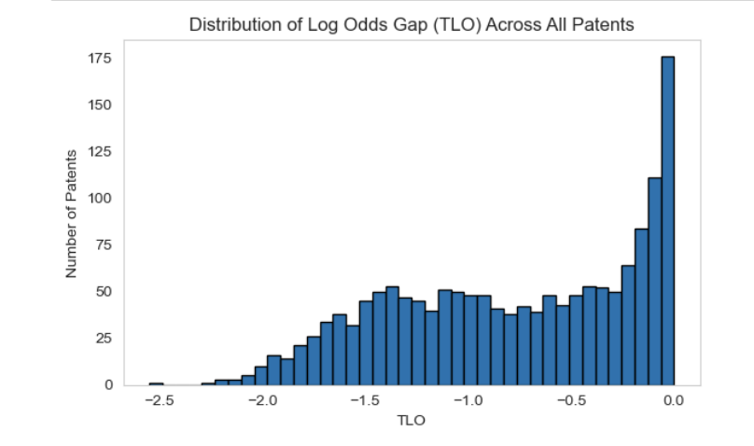
Figure 8. Topic Log Odds

5.3 Thematic Evolution of Generative AI Patents

To address the second research question, a thematic analysis was conducted using the most interpretable topic model identified in the previous section. Latent Dirichlet Allocation (LDA) was selected based on its superior semantic coherence and clearer topic separation compared to alternative models such as BERTopic. Using this model, six distinct innovation themes were extracted. Each patent was then assigned to its most representative topic, allowing for a structured exploration of how Generative AI innovations are thematically distributed and how these themes evolve over time. The number of documents associated with each topic is presented in Figure 9. Topic 5, previously labeled Representation Learning and Autoencoding Methods, appeared in 419 patents, making it the most frequent innovation theme.
It was followed by Topic 1, Language Modeling and Prompt-Based Learning, with 291 patents, indicating a strong focus in these two areas. Topics 0, 3, and 4 also had moderate representation, covering themes such as Adversarial Image Generation, Medical Imaging and Diagnostic AI, and Embedded Systems. In contrast, Topic 2, related to Audio Signal and Sequence Encoding, had the lowest number of documents (n = 174), suggesting a more niche area of innovation.

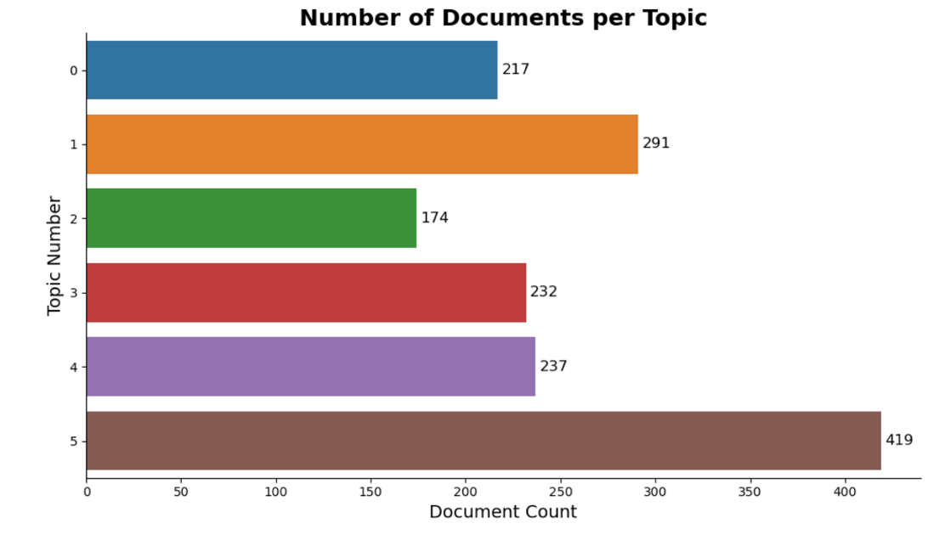
Figure 9. Number of Documents per Topic

To observe how innovation themes evolve, a yearly topic share analysis was conducted. Each year, the share of patents dominated by each topic was computed. As shown in Figure 10, Topic 1 demonstrates a strong upward trend, particularly from 2023 to 2025, indicating increasing research and commercial attention. In contrast, Topic 5, while initially dominant, appears to be stabilizing or slightly declining in recent years.
Other topics, such as Topics 4 and 3, show moderate fluctuation but no strong growth. The share of patents held by the top 5 applicants was analyzed to understand which organizations are driving innovation. Figure 11 shows how the share of patents held by the top five applicants in Generative AI changes over time, from 2021 onward. This helps us understand how different companies have increased, decreased, or maintained their focus on GenAI innovation during this period. Koninklijke Philips N.V. shows a clear increase in patent activity after 2022, which shows a growing investment in GenAI technologies. Analyzing topic assignments by applicant reveals that Koninklijke Philips N.V. is most active in Topic 3, accounting for over 60% of its patents in the dataset. Based on the top keywords and thematic labeling of Topic 3 (see Section 5.2), this theme corresponds to “Medical Imaging and Diagnostic AI”. This finding aligns closely with Philips’ known domain expertise and strategic focus in healthcare technologies. It also demonstrates how topic modeling can successfully uncover the thematic priorities of different applicants, linking technological themes to institutional actors.
The company’s secondary contributions to Topic 5 (“Representation Learning and Autoencoding”) and Topic 1 (“Language Modeling and Prompt-based Learning”) suggest additional areas of exploration but with significantly lower intensity. Overall, the results show that Philips is not just an active filer in GenAI, but a leading innovator in healthcare-related AI applications, reinforcing the model’s interpretability and its value in mapping thematic trajectories across firms.
On the other hand, Samsung Electronics Co., Ltd., which had a strong presence early on, shows a drop in patent share after 2021. This could mean a temporary slowdown or a shift in focus to other areas. At first glance, this reduction might suggest a slowdown in innovation activity. However, a closer look at the topic modeling results reveals a more nuanced explanation. Despite the drop in overall share, Samsung remains an active contributor in specific thematic areas. In particular, the company’s patents are heavily concentrated in Topic 2 and Topic 4, which together account for the majority of its filings. Based on the top keywords associated with these topics, Topic 2 appears to focus on signal processing, sequence modeling, and audio generation, while Topic 4 relates to embedded AI systems, hardware integration, and sensor-based applications. These areas are consistent with Samsung’s strategic interests in consumer electronics, smart devices, and multimedia AI technologies, suggesting that the decline in overall patent share does not indicate withdrawal but rather a refinement of scope. Instead of broad diversification, Samsung may be investing more deeply in product-specific innovations that integrate GenAI functionalities into core business areas. This pattern highlights the value of combining quantitative trend analysis with thematic topic modeling. While raw patent counts may indicate shifts in activity, topic-level insights offer a more accurate view of where innovation is actually happening. In Samsung’s case, the data suggests not a decline in innovation intensity but rather a strategic pivot toward specialized GenAI applications aligned with its existing product ecosystem. Robert Bosch GmbH shows a steady increase in patent activity through 2023, indicating a consistent and growing commitment to GenAI innovation. Tata Consultancy Services Limited maintains a strong and stable presence, reflecting sustained engagement. Siemens AG contributes at a steady but lower level, suggesting a more cautious or narrowly focused strategy. These trends highlight how some companies actively expand their innovation efforts while others take a more reserved approach.
A lifecycle analysis was carried out for each of the six LDA topics further to interpret the thematic structure of Generative AI innovation. This analysis aimed to determine the maturity stage of each theme—such as whether it is emerging, growing, or stabilizing. Two key metrics were used: the average yearly patent share (to assess a topic’s overall presence) and the Compound Annual Growth Rate (CAGR), which captures the average annual rate of change over time. Following the method proposed by Ghaffari et al. (2024), the CAGR was calculated based on the topic’s patent share in the first and final year of the observation period. Together, these measures help distinguish between well-established and rapidly expanding innovation areas, offering a more dynamic view of how thematic priorities evolve over time.
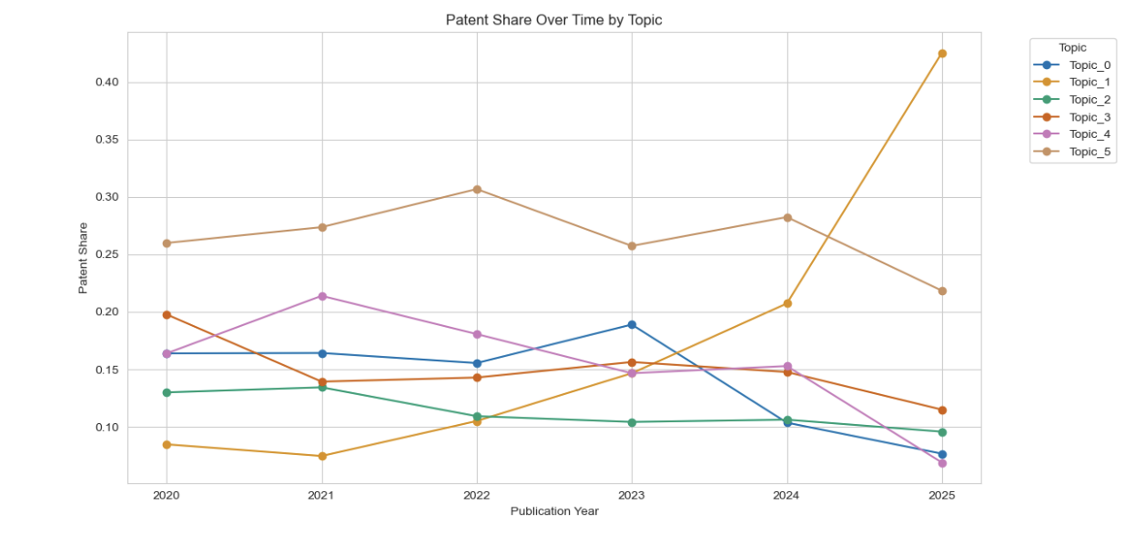
Figure 10. Patent Share over time

This approach identifies topic lifecycles in terms of patent share growth, enabling the classification of innovation themes as emerging, dominant, saturating, or declining over time (Ghaffari et al., 2024). Figure 12 synthesizes this time series data into a two-dimensional lifecycle classification. The horizontal axis reflects the average topic share, capturing overall dominance, while the vertical axis captures the CAGR, indicating the direction and intensity of change. Four quadrants emerge:

- Top-right (High Share, High Growth): Emerging and expanding themes
- Bottom-right (High Share, Negative Growth): Mature or saturated themes
- Top-left (Low Share, High Growth): Niche but growing areas
- Bottom-left (Low Share, Negative Growth): Declining themes

In this framework, Topic 1 is positioned in the emerging phase, characterized by a relatively low average patent share but a high positive growth rate, indicating increasing recent attention. Although Topic 1 holds the second-highest total document count, its average annual share over the entire period remains moderate due to limited early presence. Combined with a high positive CAGR in recent years as shown in Table 5, this positions Topic 1 in the emerging quadrant of the lifecycle matrix, reflecting its growing precence in recent patent filings.

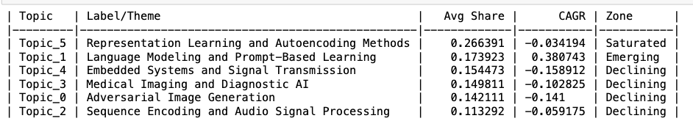
Table 5: Lifecycle Classification of GenAI Topics
Note: Topics are categorized into lifecycle based on their average annual share of patents and Compound Annual Growth Rate (CAGR) from 2021 to 2025. This classification highlights the relative maturity and dynamism of each innovation theme.

In contrast, Topic 5 lies in the saturation phase, maintaining a high overall share but showing low or slightly negative growth, suggesting it may be reaching maturity. Topics 0, 3, and 4 are classified as declining themes. While each had a moderate presence across the dataset, their consistently negative growth rates indicate a downward trend in innovation activity, suggesting they may be reaching saturation or are being deprioritized in the GenAI landscape. For example, the most frequently occurring IPC code in Topic 4 is A61B 18/12, which pertains to surgical instruments that deliver energy—such as high-frequency current—to body tissue. This indicates that earlier GenAI innovation efforts were concentrated in embedded or energy-based medical applications. The observed decline in patent filings under this code supports the broader downward trend identified in Topic 4, potentially reflecting technological saturation or a strategic shift away from this application area toward newer GenAI landscape. Lastly, Topic 2 appears relatively stable, maintaining low levels of growth. The results of the topic modeling and lifecycle analysis provide a structured view of the dominant and emerging innovation trajectories in Generative AI patent filings. Among the six identified themes, Topic 5, which relates to Representation Learning and Autoencoding Methods, holds the highest average share of patents, suggesting it has been the most actively explored domain in recent years. The most frequently associated IPC classification within this topic is G06N 3/04, covering convolutional neural networks (CNNs), a foundational architecture in deep learning. This indicates that a substantial portion of GenAI patent activity has focused on core neural model development and representation learning. However, despite its dominance, the theme exhibits a slightly negative growth rate, implying that innovation in this space may be reaching saturation, with diminishing returns or fewer breakthroughs in recent years.

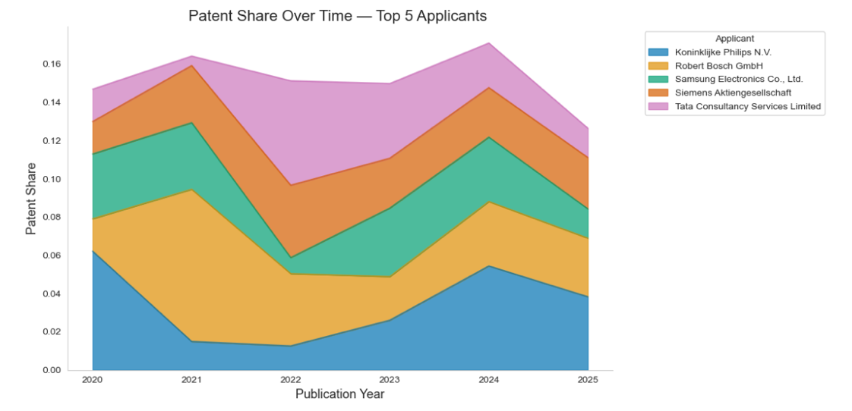
Figure 11. Patent Share Over Time — Top 5 Applicants

In contrast, Topic 1, labeled as Language Modeling and Prompt-Based Learning, demonstrates both strong growth and an increasing annual share of patent activity. While it does not hold the highest average share across the entire period, its recent acceleration places it firmly in the emerging quadrant of the topic lifecycle matrix, signaling a rapidly expanding area of strategic importance. The most frequently occurring IPC code in this theme is G06N 20/00, which covers machine learning systems that adapt based on models and data—directly aligning with the rise of large language models (LLMs) and prompt-based architectures. This convergence suggests that Topic 1 is not only gaining traction but may also become a central pillar of GenAI innovation, particularly as instruction tuning, fine-tuning, and deployment of foundational models continue to evolve.

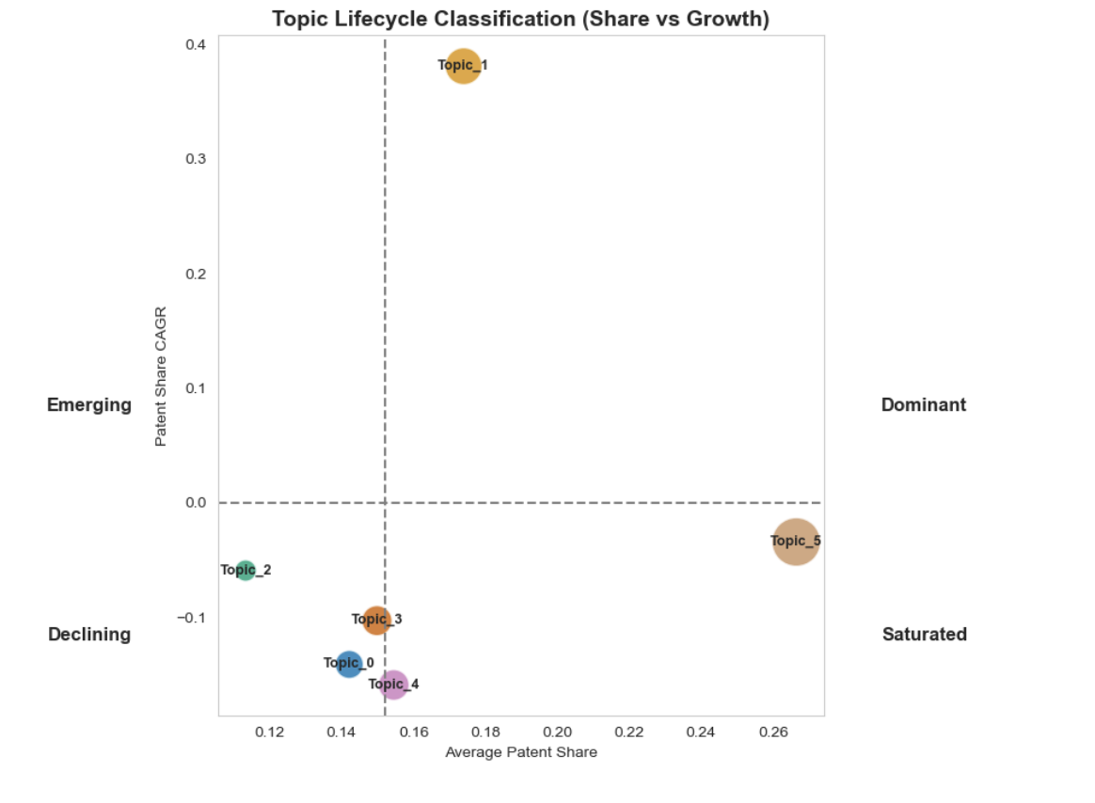
Figure 12. Topic Lifecycle Classification (Average Share vs. Growth)

In summary, the topic lifecycle analysis reveals distinct maturity levels across innovation themes in the GenAI patent landscape. While some areas like Language Modeling and Prompt-Based Learning are gaining strategic relevance, others such as Embedded Systems and Medical Imaging show signs of decline or stabilization. By combining average patent share and growth dynamics, this framework offers a nuanced view of technological evolution, highlighting where attention is intensifying, plateauing, or fading. These insights provide a valuable foundation for understanding not only where innovation is happening, but also how priorities are shifting over time across different domains of Generative AI.

5.3 Mapping Innovation Stages in Generative AI

A DoI-Theoretical Framework

To address Research Question 3—How can the thematic insights extracted from these patents inform strategic innovation decisions and reveal unexplored opportunities within the Generative AI ecosystem, particularly when framed by the Diffusion of Innovations (DoI) framework?—this section applies the DoI framework to assess the maturity and strategic positioning of different GenAI innovation themes. The DoI framework (Rogers, 2003) provides a structured way to understand how new technologies spread through time and across adopters. It segments the adoption process into five groups: Innovators, Early Adopters, Early Majority, Late Majority, and Laggards, each with distinct characteristics and risk tolerance. These categories correspond to stages of innovation maturity, from early experimentation to widespread adoption and eventual saturation. By linking these stages to topic-level trends in patent data, this study seeks to identify which innovation themes are gaining traction, which are stabilizing, and which may be in decline. To operationalize this framework, each topic was analyzed based on temporal growth patterns, adopter diversity, and technological scope. Indicators such as Compound Annual Growth Rate (CAGR), average patent share, the number of unique applicants, and IPC code variety were used to infer how widely and deeply each topic is diffusing. These indicators serve as proxies for the innovation lifecycle stages and allow for systematic classification of topics as emerging, mature, saturated, or declining. Figure 13 illustrates the applicant and technological (IPC) diversity per topic. The left panel shows the number of unique applicants per topic, reflecting how broadly innovation is pursued across organizations. Topics 4 and 5 attract the highest number of applicants, suggesting that these themes resonate widely across industrial actors. In contrast, Topics 2 and Topic 0 are adopted by fewer organizations, pointing to their potential status as either niche or early-stage innovations. On the right, the IPC count per topic captures technological diversity. Topic 4 dominates in terms of classification spread, implying cross-domain applicability and a broader technological footprint. Together, these metrics reflect the diffusion reach of each topic, topics with both high applicant and IPC diversity may be considered more embedded in the broader innovation landscape. Overall, these findings highlight that diffusion patterns are not uniform across themes: some topics (e.g., Topic 4) are more technologically expansive, while others (e.g., Topic 5) are more organization-driven, and some (e.g., Topic 2) may be specialized or underexplored. Figure 15 presents topic adoption trends over time. This line chart reveals the temporal trajectories of each theme, allowing for stage-based interpretation using the DoI framework. For instance, Topic 1 (Language Modeling and Prompt-Based Learning) shows a steep rise from 2022 onward, reflecting early-stage acceleration and positioning it in the early adopter or takeoff phase. Conversely, Topic 5 (Representation Learning and Autoencoding Methods) shows high but stabillizing activity, characteristic of a mature, potentially saturating innovation. Topics 3 and 4, which peaked earlier and now show decline, suggest movement into the late majority or even decline phase. Topic 2’s consistently low counts indicate a niche area with limited adoption.

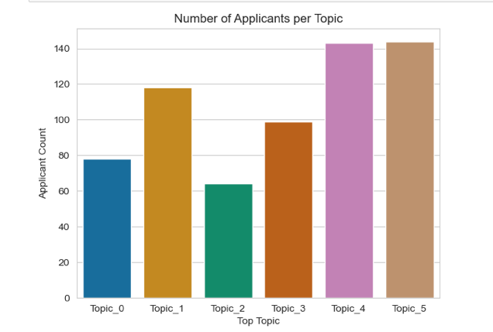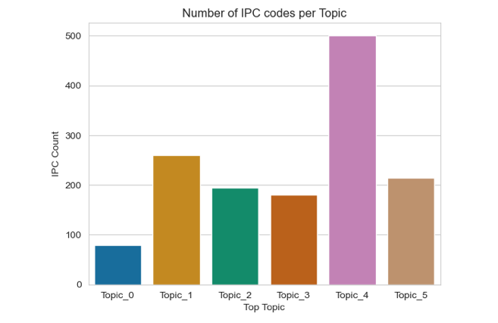
Figure 13. Applicant and Classification Diversity

By linking both figures to the Diffusion of Innovation (DoI) framework, the analysis provides actionable insights into the maturity and spread of each innovation theme, thus directly addressing RQ3. Figure 13 reveals the diversity of applicant involvement and technological scope per topic, highlighting which areas are broadly adopted across sectors (e.g., Topics 4 and 5) versus those with limited uptake (e.g., Topic 2). This helps identify underexplored domains that may represent emerging opportunities or niche applications with untapped potential. mature technology adopted by the early majority, indicating it has gained wide attention but may be approaching saturation. Figure 15 complements this by tracing adoption trends over time, helping to position each topic along the innovation lifecycle. For example, Topic 1’s sharp upward curve indicates accelerating diffusion, suggesting early-stage growth that may justify increased strategic focus and investment. In contrast, Topic 5’s plateau implies a mature space where incremental innovation dominates, potentially requiring differentiation or value-based strategies.

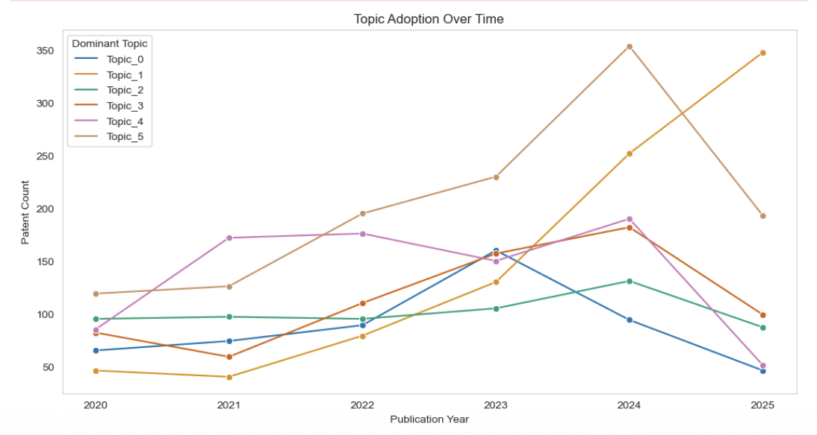
Figure 15. Patent Adoption Trends by Topic

To further contextualize the diffusion of innovation within Topic 1 (Language Modeling and Prompt-Based Learning), a granular analysis was performed at the applicant level. Specifically, the cumulative patent shares of Koninklijke Philips N.V., one of the most active organizations in this topic, were tracked over time and mapped to the stages of the Diffusion of Innovation (DoI) framework. Each IPC-applicant pair was assigned to one of the five adoption stages: Innovators, Early Adopters, Early Majority, Late Majority, or Laggards. This method follows standard interpretations from the Diffusion of Innovation (DoI) framework (Rogers, 2003), where different adopter groups emerge at predictable intervals along the innovation adoption curve. Specifically, thresholds were applied as follows: a cumulative share of up to 5% was categorized as Innovators, reflecting early experimental engagement; 5%–16% as Early Adopters, representing organizations that validate and refine emerging ideas; 16%–50% as the Early Majority, signaling a growing commitment to scale; 50%–84% as the Late Majority, indicating broader but more cautious adoption; and anything above 84% as Laggards, who adopt only when the innovation is widely proven or established. The specific percentage thresholds are not arbitrary but are derived from Everett Rogers' 1962 Diffusion of Innovations theory, which models the spread of new ideas through a population using a normal distribution (bell curve). The validity of the lifecycle segmentation is further reinforced by descriptive statistics. Innovator-stage IPC-applicant pairs exhibit cumulative shares between 2.5% and 5%, while Early Adopters cluster around a mean of 10.7%. The progression continues consistently into the Early Majority (mean 33.2%), Late Majority (67.3%), and Laggards (92.6%), supporting the structured adoption curve expected by the Diffusion of Innovation model. This confirms that the segmentation reflects underlying adoption realities rather than arbitrary thresholds. As shown in Figure 16, Koninklijke Philips N.V. shows adoption patterns ranging from the Innovator stage (e.g., G05B 15/00 in 2025) to the Early Majority stage (e.g., G06N 3/02 in 2024), reflecting a gradual but structured expansion into generative AI domains. This lifecycle mapping highlights the organization’s strategic transition from early experimentation toward more mainstream technological adoption.

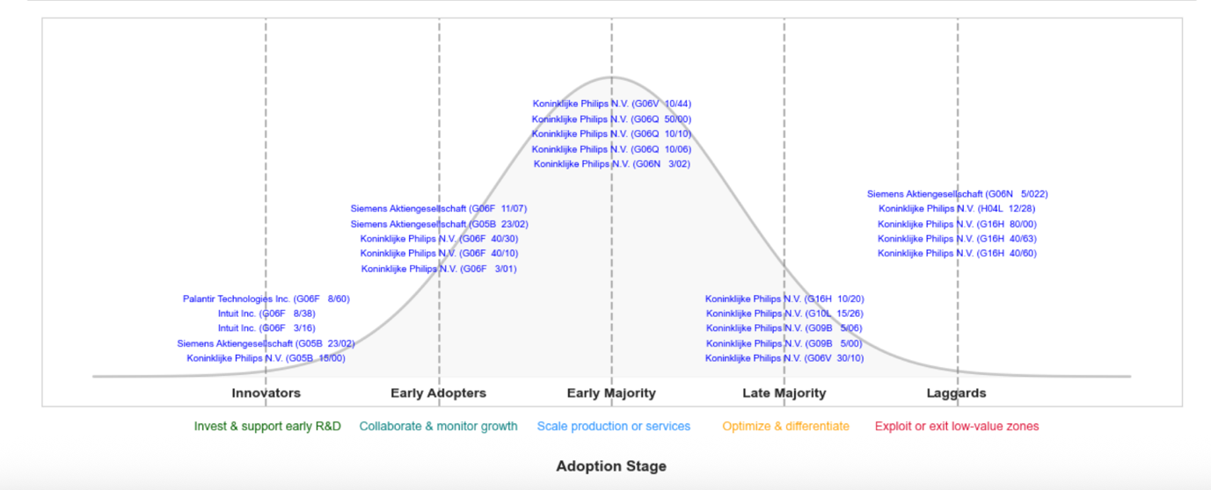
Figure 16. Adoption stage

While this section illustrates the lifecycle dynamics for a single organization within Topic 1, the same analytical approach can be extended to other topics and applicants. However, to maintain clarity and avoid excessive detail, only one representative case is discussed here.
The findings reveal a clear trajectory of strategic engagement. In 2025, Philips held a 4% cumulative share in IPC code G05B 15/00, placing it within Innovator stage. This suggests early experimentation with GenAI technologies before broad market validation. Three additional IPC codes, G06F 3/01, G06F 40/10, and G06F 40/30, also appear in 2025 but fall within the Early Adopter range (5–16%), indicating that Philips was among the first wave of organizations to begin structured exploration of transformer-based or prompt-driven applications. By 2024, Philips had reached the Early Majority stage in IPC code G06N 3/02, signaling that select GenAI capabilities were being scaled and integrated more broadly into its technological portfolio. This micro-level analysis demonstrates how even within a single organization, the adoption of generative AI themes can span multiple lifecycle stages depending on the specific technological area. It also highlights how firms evolve their innovation strategies over time, from early experimentation to strategic expansion. When interpreted through the DoI prespective, such patterns help explain not only when but also how firms adopt emerging technologies, offering actionable insight into organizational innovation trajectories.
Ultimetly, these findings support RQ3 by showcasing how thematic and temporal patent data, when analyzed through the DoI framework, can guide strategic innovation planning, identify potential early-stage partnerships, and reveal opportunities in underexplored technical areas.

Chapter 6

Conclusion and Future Work

This thesis set out to investigate the thematic and temporal dynamics of innovation within the field of Generative AI, using a comprehensive patent dataset and a combination of topic modeling and diffusion-based analysis. The study identified six distinct technological themes, each with varying degrees of maturity, adoption, and strategic relevance. By applying multiple topic modeling algorithms and validating results both quantitatively and qualitatively, the analysis revealed a nuanced innovation landscape characterized by a shift from traditional multimodal and embedded systems toward more text-centric and prompt-driven technologies.
Topic 1, centered on language modeling and prompt-based learning, emerged as the most strategically important frontier, combining high growth with increasing diffusion. In contrast, Topic 5, associated with representation learning and autoencoding methods, has entered a saturated phase, with widespread but decelerating innovation activity. The use of the Diffusion of Innovations (DoI) framework further allowed for the classification of applicants across lifecycle stages, identifying early pioneers such as Bosch and Tata, and lagging adopters like Philips and Siemens in selected topics. These insights offer practical implications for strategic innovation management by identifying which themes provides ground for further investment, collaboration, or potential deprioritization.
Despite these contributions, several limitations should be acknowledged. First, patent data may not fully capture informal or open-source innovation pathways that are particularly relevant in the AI domain. Second, the use of IPC codes and applicant names as proxies for technological and organizational behavior introduces abstraction that may overlook qualitative nuances. Lastly, the diffusion analysis assumes a relatively linear adoption model, which may not fully capture the feedback loops and discontinuities characteristic of AI innovation.
Future work could extend this study in multiple directions. Incorporating citation networks or inventor collaboration graphs could yield deeper insight into knowledge flows and innovation clusters. Additionally, integrating external datasets, such as research publications, venture capital activity, or open-source contributions, would help validate the findings and address the limitations of patent-only analysis. Overall, this thesis provides an evidence-based foundation for understanding the evolving structure of Generative AI innovation and contributes a novel methodological approach for translating patent data into strategic foresight.

References

World Intellectual Property Organization. (2023). Patent landscape report: Generative artificial intelligence (GenAI) — Appendices. WIPO. https://www.wipo.int/web-publications/patent-landscape-report-generative-artificial-intelligence-genai/en/appendices.html

Dernis, H., Calvino, F., Moussiegt, L., Nawa, D., Samek, L., & Squicciarini, M. (2023). Identifying artificial intelligence actors using online data. OECD. https://www.researchgate.net/publication/369362298

European Patent Office. (2022). Espacenet – pocket guide. European Patent Office. https://link.epo.org/web/technical/espacenet/espacenet-pocket-guide-en.pdf

European Patent Office. (2025, February 24). Why switch to the current Espacenet version? European Patent Office. https://www.epo.org/en/searching-for-patents/helpful-resources/patent-knowledge-news/why-switch-current-espacenet-version

Chang, J., Boyd-Graber, J., Gerrish, S., Wang, C., & Blei, D. (2009). Reading Tea Leaves: How Humans Interpret Topic Models. Advances in Neural Information Processing Systems, 22.

Abdelrazek, M., Elbassuoni, S., Faralli, S., & Ortega, F. (2023). Topic modeling algorithms and applications: A survey. Information Systems, 112, 102131. https://doi.org/10.1016/j.is.2022.102131

Newman, D., Lau, J. H., Grieser, K., & Baldwin, T. (2010). Automatic evaluation of topic coherence. In Proceedings of the 2010 Annual Conference of the North American Chapter of the Association for Computational Linguistics: Human Language Technologies (pp. 100–108). Association for Computational Linguistics. https://www.researchgate.net/publication/220817098

Ghaffari, M., Aliahmadi, A., Khalkhali, A., Zakery, A., Daim, T. U., & Zamani, M. (2024). Exploring the technological leaders using tire industry patents: A topic modeling approach. Technology in Society, 78, 102664.
https://www.sciencedirect.com/science/article/pii/S0160791X24002124

Janani, R., & Vijayarani, S. (2016). Text mining research: A survey. International Journal of Innovative Research in Computer and Communication Engineering, 4(4), 5845–5852.
https://www.researchgate.net/publication/339552018_Text_Mining_Research_A_Survey

Blei, D. M., & Lafferty, J. D. (2009). Topic models. In A. Srivastava & M. Sahami (Eds.), Text Mining: Classification, Clustering, and Applications (pp. 71–94). Chapman and Hall/CRC.
https://aclanthology.org/W14-3110/

Gupta, R. K., Agarwalla, R., Naik, B. H., Evuri, J. R., Thapa, A., & Singh, T. D. (2022). Prediction of research trends using LDA based topic modeling. Global Transitions Proceedings, 3(1), 298–304. https://doi.org/10.1016/j.gltp.2022.03.015

Grootendorst, M. (2022). BERTopic: Neural topic modeling with a class-based TF-IDF procedure. arXiv. https://arxiv.org/abs/2203.05794

Ghaffari, M., Aliahmadi, A., Khalkhali, A., Zakery, A., Daim, T. U., & Zamani, M. (2024). Exploring the technological leaders using tire industry patents: A topic modeling approach. Technology in Society, 78, 102664.
https://doi.org/10.1016/j.techsoc.2024.102664

Hall, B. H., & Harhoff, D. (2012). Recent research on the economics of patents. Annual Review of Economics, 4, 541–565. https://doi.org/10.1146/annurev-economics-080511-111008

Dhingra, S., Singh, M., SB, V., Malviya, N., & Gill, S. S. (2023). Mind meets machine: Unravelling GPT-4's cognitive psychology. arXiv. https://arxiv.org/abs/2303.11436
Sengar, S. S., Hasan, A. B., Kumar, S., & Carroll, F. (2024). Generative artificial intelligence: A systematic review and applications. arXiv. https://arxiv.org/abs/2405.11029

World Intellectual Property Organization. (n.d.). Generative AI. WIPO. https://www.wipo.int/en/web/patent-analytics/generative-ai

Kherwa, P., & Bansal, P. (2019, July). Topic modeling: A comprehensive review. EAI Endorsed Transactions on Scalable Information Systems, 6(22), 159623. https://doi.org/10.4108/eai.13-7-2018.159623

Singh, S., Singh, S., Kraus, S., Sharma, A., & Dhir, S. (2024). Characterizing generative artificial intelligence applications: Text-mining-enabled technology roadmapping. Journal of Innovation & Knowledge, 9(3), 100531. https://doi.org/10.1016/j.jik.2024.100531

Dwivedi, Y. K., Sharma, A., Rana, N. P., Giannakis, M., Goel, P., & Dutot, V. (2023). Evolution of artificial intelligence research in Technological Forecasting and Social Change: Research topics, trends, and future directions. Technological Forecasting and Social Change, 192, 122579. https://doi.org/10.1016/j.techfore.2023.122579

Gupta, P., Ding, B., Guan, C., & Ding, D. (2024). Generative AI: A systematic review using topic modelling techniques. Data and Information Management, 8(2), 100066. https://doi.org/10.1016/j.dim.2024.100066

Zhang, H., Daim, T., & Zhang, Y. (2021). Integrating patent analysis into technology roadmapping: A latent Dirichlet allocation-based technology assessment and roadmapping in the field of blockchain. Technological Forecasting and Social Change, 167, 120729. https://doi.org/10.1016/j.techfore.2021.120729

Liu, N., Shapira, P., Yue, X., & Guan, J. (2021). Mapping technological innovation dynamics in artificial intelligence domains: Evidence from a global patent analysis. PLOS ONE, 16(12), e0262050. https://doi.org/10.1371/journal.pone.0262050

Choe, H., Lee, D. H., Seo, I. W., & Kim, H. D. (2013). Patent citation network analysis for the domain of organic photovoltaic cells: Country, institution, and technology field. Renewable and Sustainable Energy Reviews, 26, 492–505. https://doi.org/10.1016/j.rser.2013.05.037

Obreja, D., Rughinis, R., & Rosner, D. (2024). Mapping the conceptual structure of innovation in artificial intelligence research: A bibliometric analysis and systematic literature review. Journal of Innovation & Knowledge, 9, 100465. https://doi.org/10.1016/j.jik.2024.100465

Duch, J., & Arenas, A. (2005). Community detection in complex networks using extremal optimization. Physical Review E, 72(2), 027104. https://doi.org/10.1103/PhysRevE.72.027104

Murray, F., & Stern, S. (2005). Do formal intellectual property rights hinder the free flow of scientific knowledge? An empirical test of the anti-commons hypothesis. Journal of Economic Behavior & Organization, 63(4), 648–687. https://doi.org/10.1016/j.jebo.2006.05.017

Saxena, A., & Iyengar, S. (2020). Centrality measures in complex networks: A survey. arXiv preprint arXiv:2011.07190. https://arxiv.org/abs/2011.07190

Krakowski, S. (2025). Human-AI agency in the age of generative AI. Information and Organization, 35(1), 100560. https://doi.org/10.1016/j.infoandorg.2025.100560

Shomee, H. H., Wang, Z., Ravi, S. N., & Medya, S. (2024). A comprehensive survey on AI-based methods for patents. arXiv preprint arXiv:2404.08668. https://arxiv.org/abs/2404.08668

Toetzke, M., Probst, B., & Feuerriegel, S. (2023). Leveraging large language models to monitor climate technology innovation. Environmental Research Letters, 18(9), 091004.
https://www.researchgate.net/publication/373290858_Leveraging_large_language_models_to_monitor_climate_technology_innovation

Zhou, Y., Liu, J., & Kröger, P. (2024). Unlocking the potential of generative AI for patent analysis (arXiv preprint arXiv:2406.19465). https://doi.org/10.48550/arXiv.2406.19465

Rogers, E. M. (1962). Diffusion of innovations. Free Press.
https://teddykw2.wordpress.com/wp-content/uploads/2012/07/everett-m-rogers-diffusion-of-innovations.pdf

Diesner, J., & Carley, K. (2010, August). A methodology for integrating network theory and topic modeling and its application to innovation diffusion. In 2010 IEEE Second International Conference on Social Computing (pp. 687–692). IEEE. https://doi.org/10.1109/SocialCom.2010.106

European Patent Office. (n.d.). Expert services. https://data.epo.org/expert-services/

European Patent Office. (n.d.). CPC Text Categoriser. https://epn.epo.org/cpc-text-categoriser

Feldman, R., & Sanger, J. (2006). The text mining handbook: Advanced approaches in analyzing unstructured data. Cambridge University Press. https://www.researchgate.net/publication/280113623_The_Text_Mining_Handbook_Advanced_Approaches_in_Analyzing_Unstructured_Data

Vijayarani, S., & Janani, R. (2016). Text mining: Open source tokenization tools—An analysis. Advanced Computational Intelligence: An International Journal, 3(1), 37–47.
https://www.scirp.org/reference/referencespapers?referenceid=2393442

Blei, D. M., Ng, A. Y., & Jordan, M. I. (2003). Latent Dirichlet allocation. Journal of Machine Learning Research, 3, 993–1022.
https://dl.acm.org/doi/10.5555/944919.944937

Sievert, C., & Shirley, K. (2014). LDAvis: A method for visualizing and interpreting topics. In J. Chuang, S. Green, M. Hearst, J. Heer, & P. Koehn (Eds.), Proceedings of the Workshop on Interactive Language Learning, Visualization, and Interfaces (pp. 63–70). Association for Computational Linguistics. https://doi.org/10.3115/v1/W14-3110

Qaiser, S., & Ali, R. (2018). Text mining: Use of TF-IDF to examine the relevance of words to documents. International Journal of Computer Applications, 181(1). https://doi.org/10.5120/ijca2018917395
Chang, J., Boyd-Graber, J., Gerrish, S., Wang, C., & Blei, D. (2009). Reading tea leaves: How humans interpret topic models. Advances in Neural Information Processing Systems, 22, 288–296.
https://www.researchgate.net/publication/221618226_Reading_Tea_Leaves_How_Humans_Interpret_Topic_Models

Appendicies
Appendix A

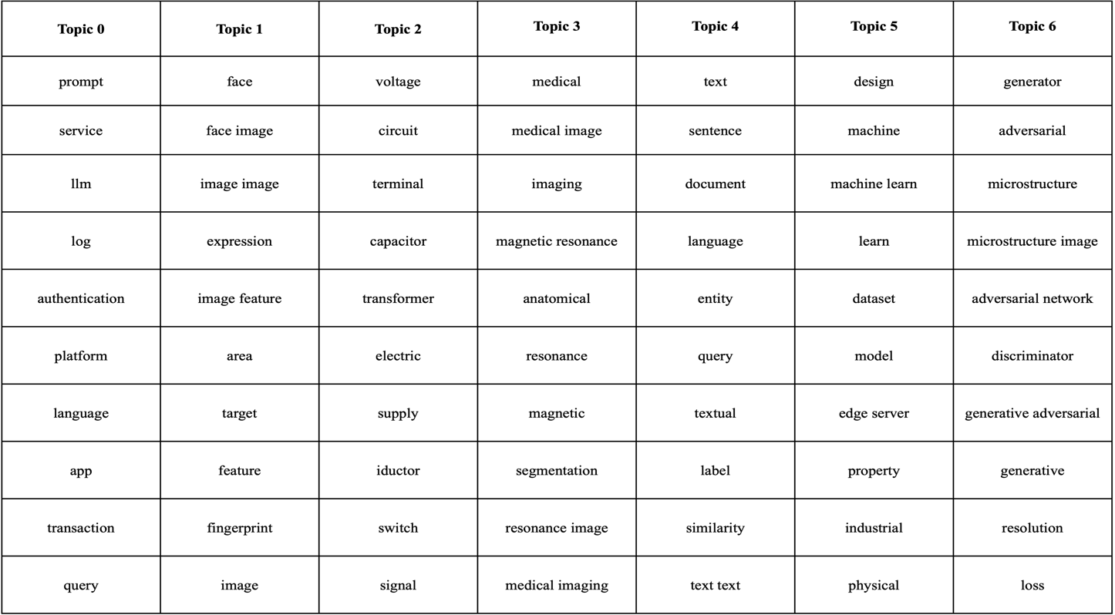
Table 2. Representative terms across the 7 topics from the best-performing BERTopic summary model

Appendix B

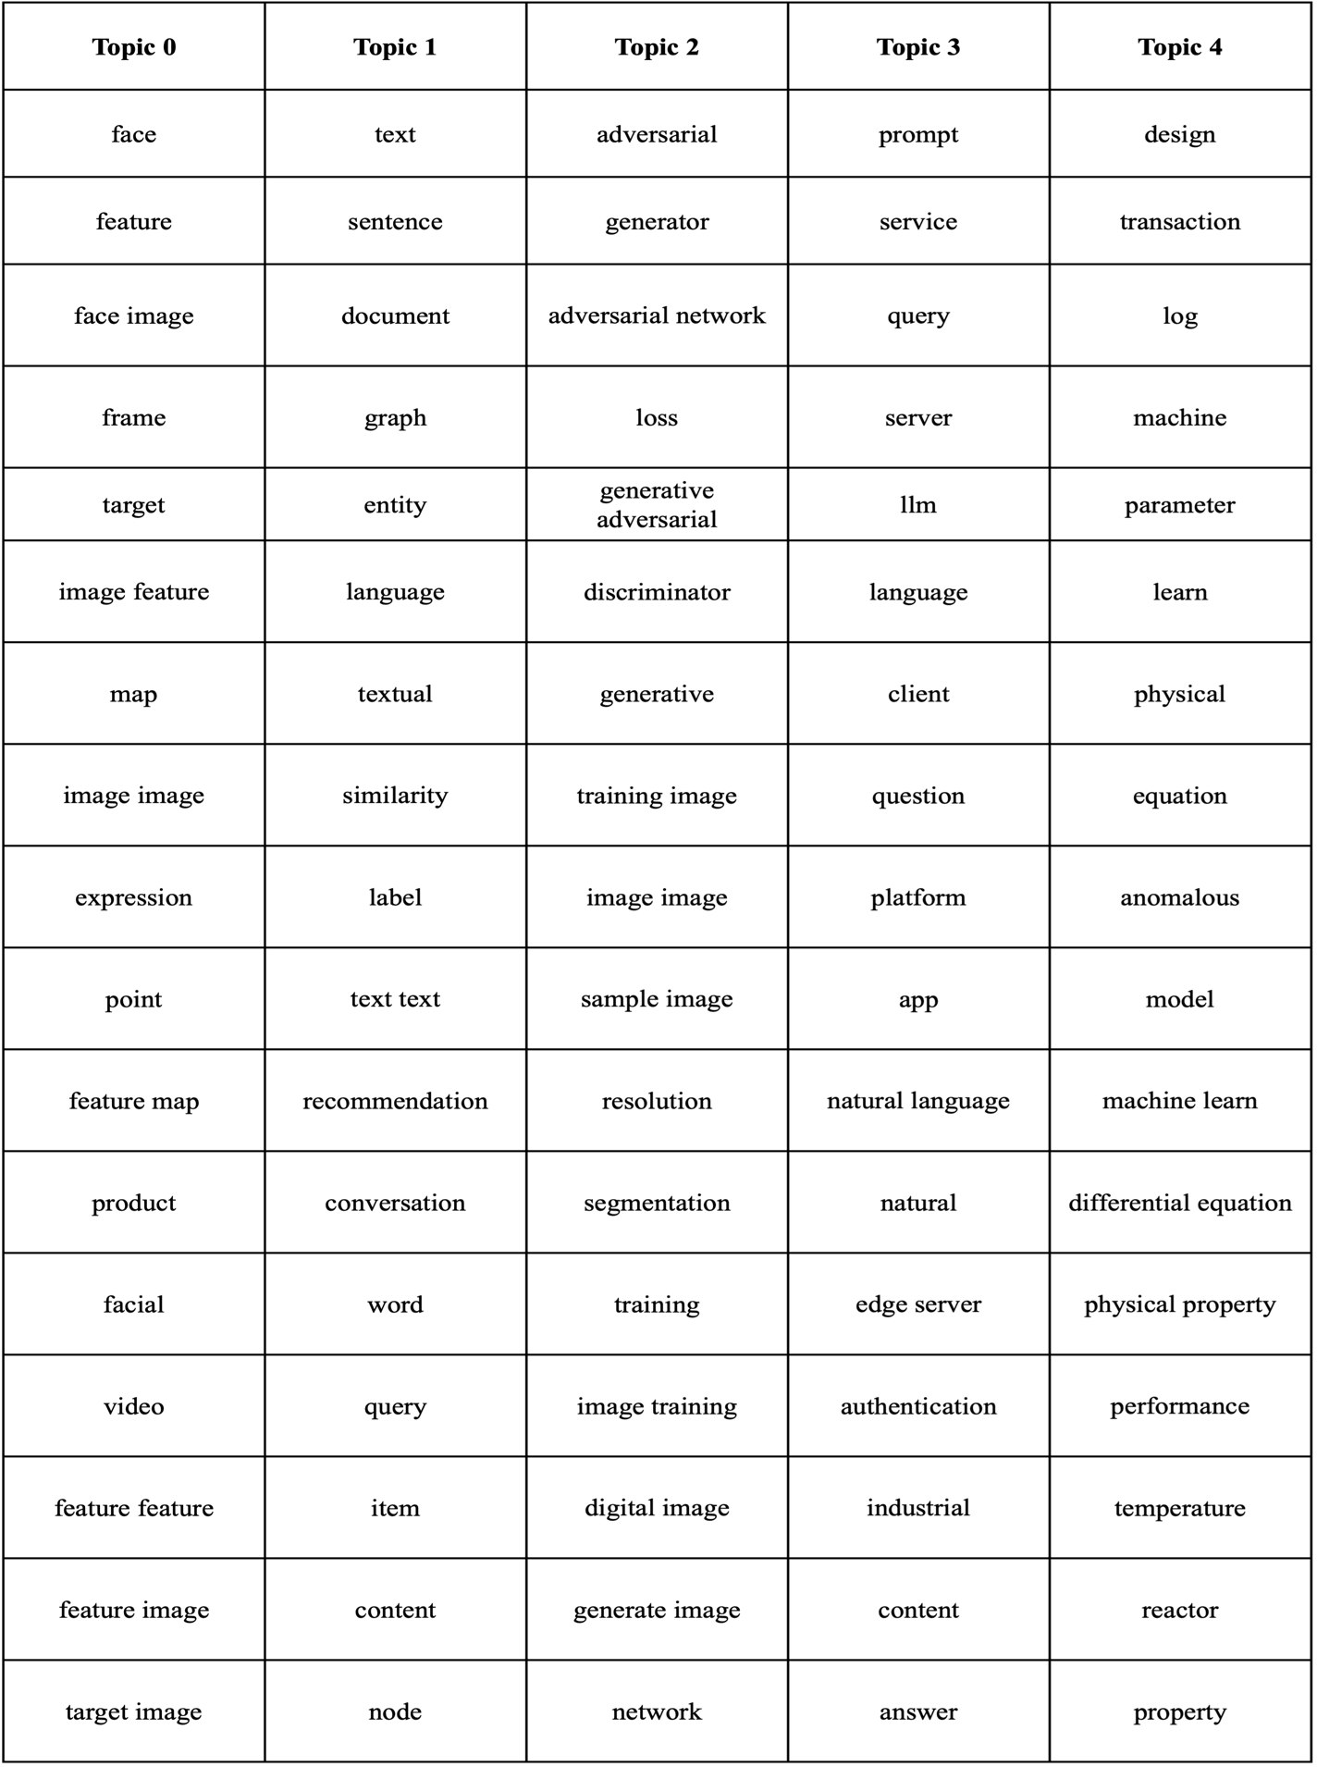
Table 3. Representative terms across the 5 topics from the best-performing BERTopic chunk model

Appendic C

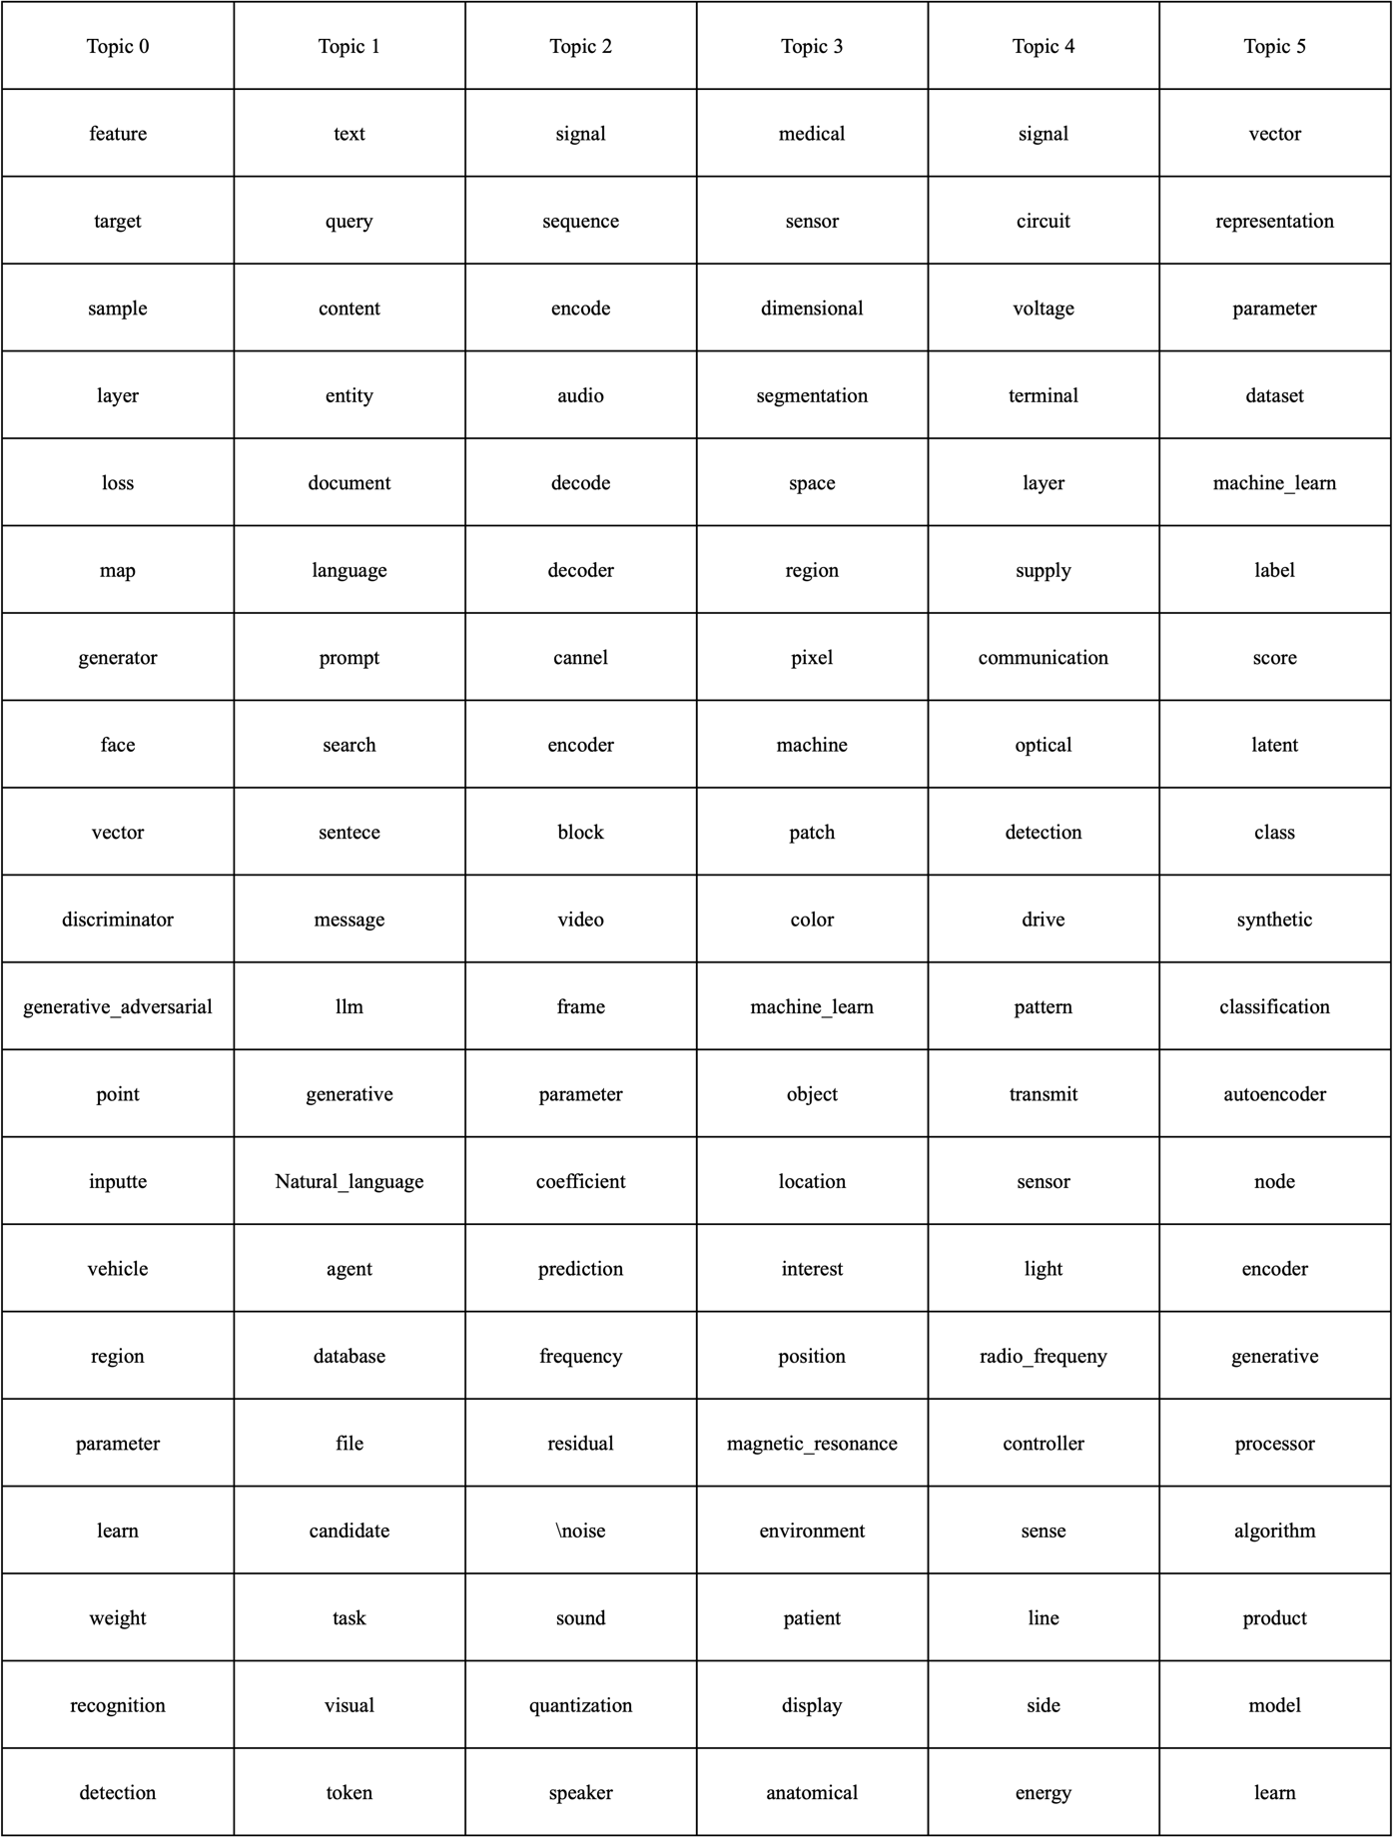
Table 4. Representative terms across the 6 topics from the best-performing LDA model

Statement of Originality

Statement of GenAI use

SDG Statement

https://maartengr.github.io/BERTopic/getting_started/distribution/distribution.html#example
https://patentscope.wipo.int/search/en/WO2022224698
Philips Healthcare

